Memory

Paraphrase of Parkinson’s Law, “Programs expand to fill the memory available to hold them.”

* Memory always is not enough.
* You will have programs to fill the memory.

Average home computer nowadays has 150 000 times more memory than the IBM 7094 (32k words), the largest computer in the world in the early 1960s.

* Memory still not enough.

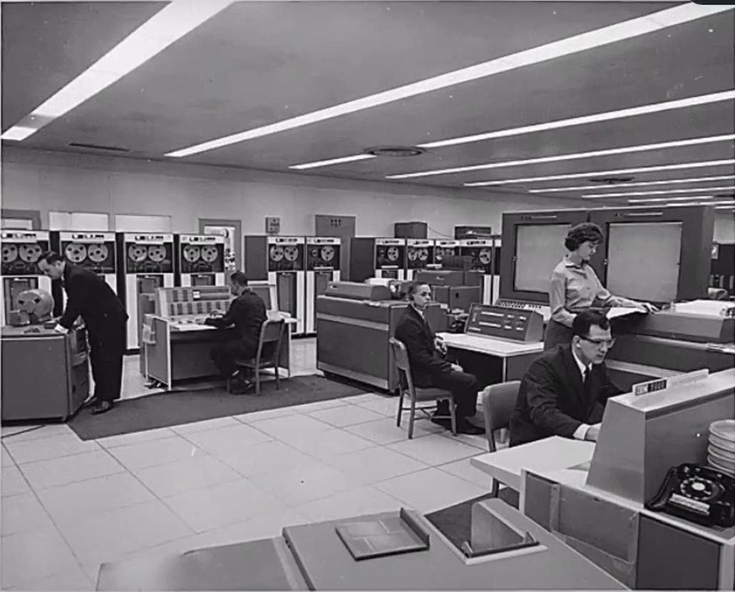

*7090 worth $20 million in 2019*

Memory Management

Main memory is a resource

OSs have to manage it

Could have been simple: put the OS at the bottom, and the application gets the rest

Not so…

No Memory Abstraction

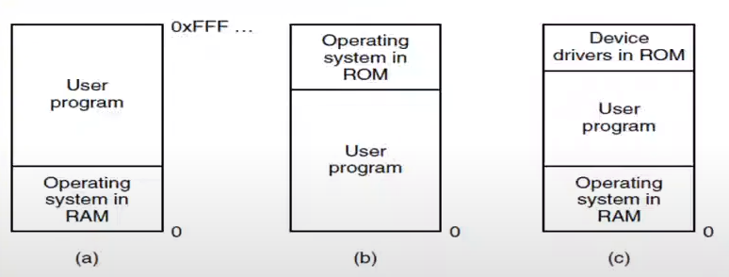

(a) and (c): user programs can wipe out the OS mistakenly

* a – old main frames (60s)
  + When I need sth from OS, I make a function call, not a system call.
* b – some embedded systems
* c – early MSDOS systems (80s)

There was no protection, no second program, no scheduling.

This is not the case, we have to manage many programs at the same time in our memory.

We use OS to manage the resources and abstracting the details of hardware.

OS control the memory management unit.

We can’t share the memory between the programs, our virtual memory cannot be larger than physical memory, etc.

Running Multiple Programs Without a Memory Abstraction

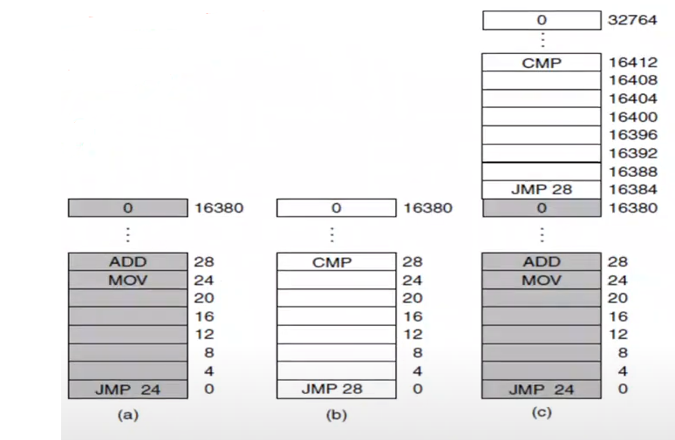

*Figure 3-2. Illustration of the relocation problem.*

*(a) A 16-KB program (b) Another 16-KB program (c) The 2 programs loaded consecutively into memory*

I have large enough memory and I want to do multiprogramming.

I have large enough memory so I can load 2 programs at the same time. Then I do scheduling, sometimes A runs sometimes B runs.

When program A runs, it is OK.

When program B runs, it says jump 28. It is address of A. We have this problem because OS or hardware is not helping. There is no protection between A and B. They can read each other’s data.

Also there is relocation problem. If I relocate A or B, other than 0 some other part of the memory, they will not run. They will produce nonsense results. Then they crash most probably.

Static Relocation

At program load time, the execution address is known

* At load time, I will find all the instructions that refer to your memory, and for example, I will add 28 with 16384.
* I did the same thing but since my relocation will be at 0, nothing changes for A.

Add the actual offset to the presumed location specified by the compiler and linker

* Compiler and linker says which instructions refer to memory so that you can change them

The cost of this – that is, the # of words that need to be relocated – varies depending on the hardware architecture and compiler

* Expensive bc everytime we load a program, we need to make modfiications. That’s ok bc we do it only once when I load the program.

No protection

* A knowingly or unknowingly can read or write to B’s address space.
* If I try to load everything to my memory at once, I will run out of memory.

A Memory Abstraction: Address Spaces

Multi programming and memory protection are not easy without abstraction

An address space is the set of addresses that a process can use to address memory

* Processes and threads are abstraction mechanism of CPU and they are supported by OS.
* Address space is abstraction mechanism of memory.

Each process has its own address space, independent of those belonging to other processes

* Address space starts from 0 and goes up to some large number.
* Those are just virtual addresses, not physical addresses.
* OS and hardware make transition between virtual address and physical address.
* It is like processes. Each process thinks that CPU belongs to it but in fact it is time sharing the CPU with other processes. In this case each process thinks it has its own address space starting from 0. It is space sharing the memory.

Just as the process concept creates a kind of abstract CPU to run programs, the address space creates a kind of abstract memory for programs to live in

2 problems have to be solved: protection and relocation.

* Base and limit registers provide protection.
* We are gonna see relocation.

Base and Limit Registers

We get some help from hardware

Simple version of dynamic relocation

Map each process’ address space onto a different part of physical memory

The contents of the base register is added to all memory references

Any memory reference larger than the limit register is invalid and causes a trap

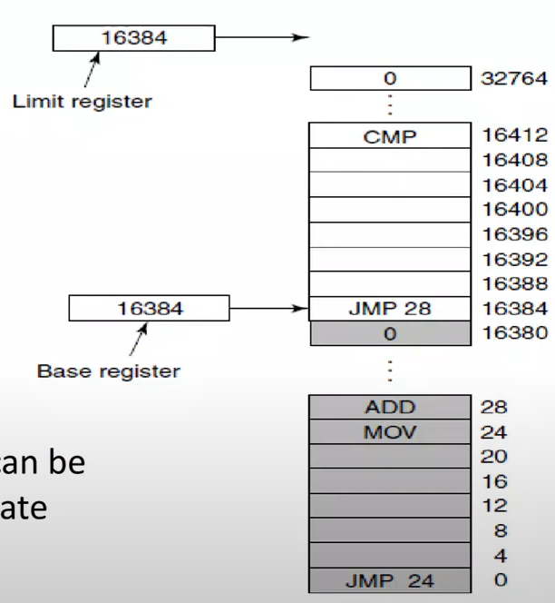Each program has base (starting address) and limit (ending address) registers.

Hardware automatically adds 28 with base register.

Addition is now dynamic and done by hardware.

CPU is now connected to bus through MMU. MMU has these two base and limit registers.

Whenever CPU says JMP 28, MMU adds content of base register with 28 and memory will get added value automatically.

When context switch happens, I change base and limit registers.

If the added value is larger than limit register, then hardware produces an interrupt that is handled by OS. That would be a segmentation fault-limit fault-memory fault.

*Figure 3-3. Base and Limit registers can be used to give each process a separate address space.*

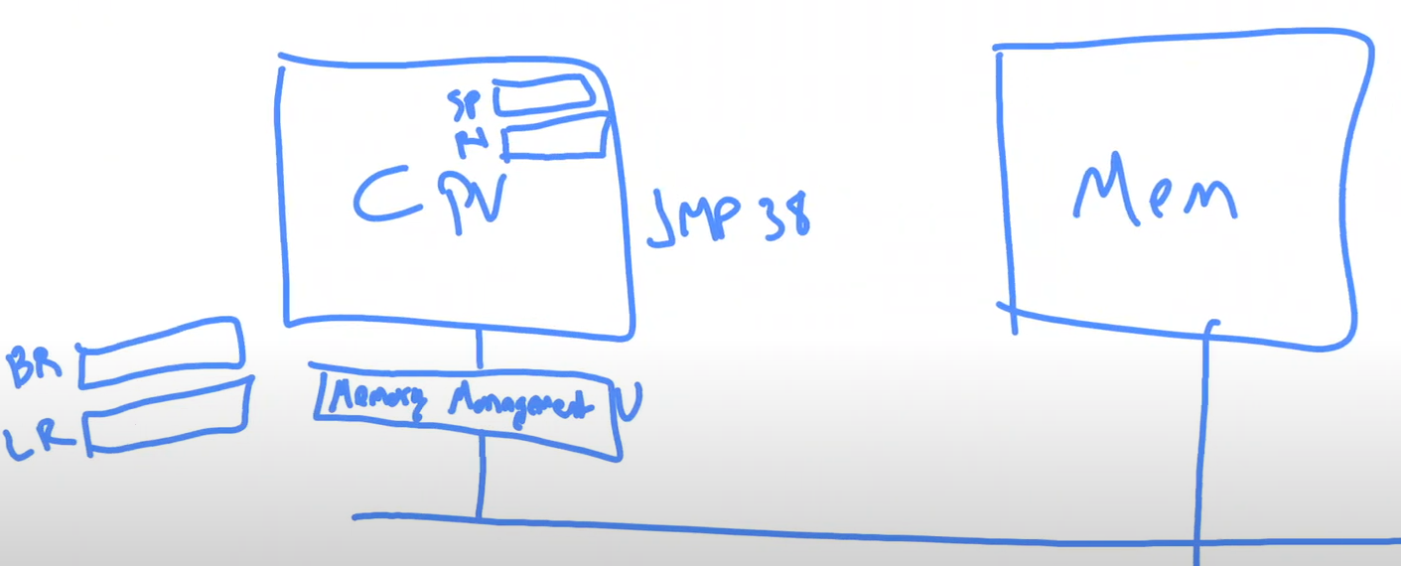

OS is piece of code. You don’t do addition in there. All OS does is, whenever a new process starts, it sets the base register and limit register. Rest is handled by MMU.

Setting BR and LR requires privileged instructions bc no ordinary process should be able to change their values.

I still have to load whole program into memory for A and B.

***Disadvantage:***

* every memory reference is an addition and comparison. Addition expensive, why?
  + Because with addition, you have to do addition between 2 digits, look at carry, … it is sequential and it takes time.
* Large programs that do not fit the memory!
* ---
* Solution 🡪 swapping and virtual memory

Swapping

Physical memory is not large enough to hold all the processes.

*Swapping*: Write the entire program out to disk when it is blocked (another solution is virtual memory – partial programs)

Read it all back in again, possibly at a different address, when it’s ready to run

Can use this to compact memory (expensive)

Apparently frees up the memory, but disk I/O consumes memory bandwidth

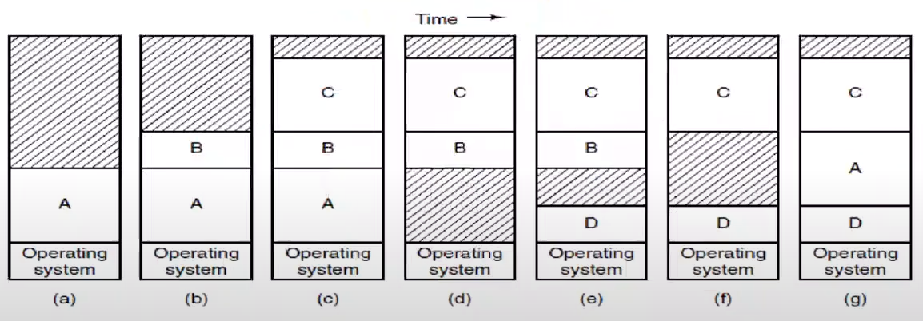



*Memory allocation changes as processes come into memory and leave it. The shaded regions are unused memory.*

I don’t have enough space so when D comes, I remove A which is not finished yet. Maybe I load some part of A back to disk.

If I had red parts in contiguous configuration, maybe A would fit in.

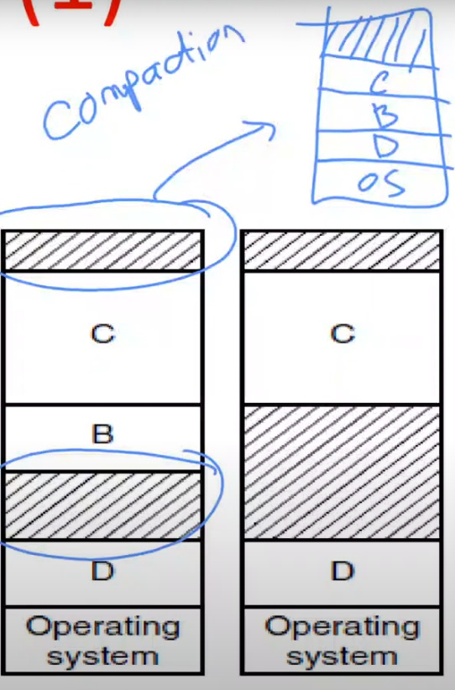When you compact your memory, you might have enough space for A.

Compaction is expensive. You have to move the processes around a lot.

From time to time, I have to compact the memory so that I have enough contiguous space for some of the processes.

Swapping the all programs back and forth between the main memory and disk is gonna be expensive. We need some other solutions.

Partial programs:

* As a programmer, I say that my program consist of 4 parts. These parts are overlays.
* Whenever OS needs to swap out my program, it doesn’t have to swap out the whole program but some part of it.
* Program may say “I am gonna keep overlay 1 and 2 in memory, 3 and 4 can stay on disk.”

Software developer needs to know about the details of the memory. What fits in memory, when should I swap out/in etc.

How much memory should be allocated for a process?

* It is probably a good idea to allocate a little extra memory whenever a process is swapped in or moved
* However, when swapping processs to disk, only the memory actually in use should be swapped

External fragmentation 🡪 Sometimes some places are not usable. You have to move things around.

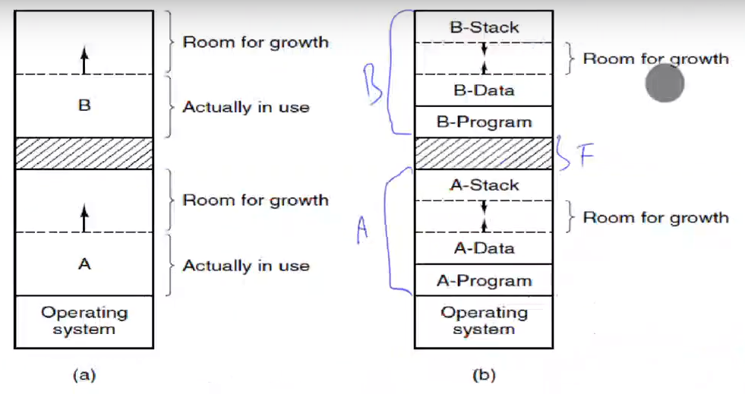

*(a) Allocating space for a growing data segment*

*(b) Allocating space for a growing stack and a growing data segment*

Memory Management

When memory is assigned dynamically, the OS must manage it.

* OS should know what part of the memory is free. It should keep some kind of data structure.

In general terms, there are 2 ways to keep track of memory usage:

1. bitmaps
2. free lists

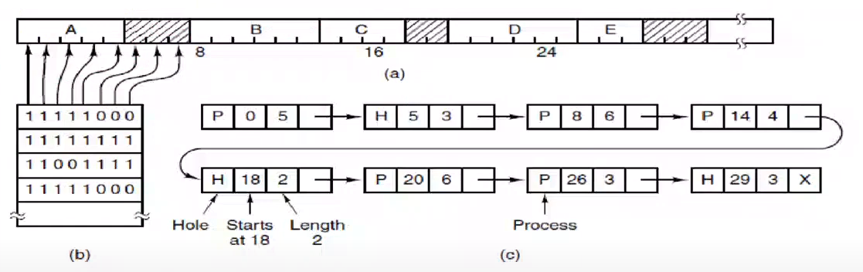

*(a) A part of memory with 5 processes and 3 holes. The tickmarks show the MMUs. The shaded regions (9 in the bitmap) are free.*

*(b) The corresponding bitmap.*

*(c) The same information as a list.*

I use a bit for each 16 KB of memory.

Memory Management with Bitmaps

Bitmaps: memory is divided into allocation units

Size of the allocation unit is a design issue: What is the tradeoff?

Searching for K allocation units is expensive

Memory Management with Linked Lists

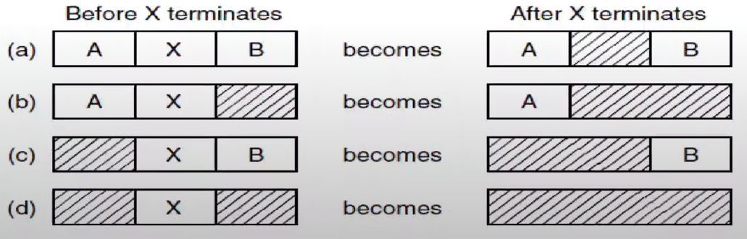

*4 neighbor combinations for the terminating process, X*

*THIS PAGE IS NOT MUCH IMPORTANT, YOU CAN SKIP*

Memory Management Algorithms

* First fit
  + Traverse the list until a large-enough block is found
  + Allocate as much of it as is needed
  + Return the rest to the free list
  + When freeing memory, must merge adjacent blocks
  + Obvious answer: order linked list by address
* Next fit
  + Next search starts from the result of previous search
* Best fit
  + First fit seems wasteful – there may be an exact match further down the list
  + Solution: best fit
  + Find the free block that’s closest in size to the request
  + Obvious data structure: order linked list by size
  + Makes merging less efficient
  + And best fit isn’t more efficient! More wasted memory: why?
* Worst fit
  + Best fit tends to leave small, useless blocks (fragmentation)
  + What about worst fit – pick the largest block and sub-divide it?
  + That’s not very good, it turns out; first fit and best fit are better and pretty close
  + Note: this is a simulation result based on trace data
  + For first fit, as much as 1/3 of memory may be unusable!
  + Many other algorithms
* Quick fit

Better implementation:

* Keep the hole list and process list separate
* Hole list can directly use the free memory!

Overlays

There is a need to run programs that are too large to fit in memory

Solution adopted in the 1960s, programmers split programs into little pieces, called overlays

Kept on the disk, swapped in and out of memory by the program itself

Virtual Memory

*Virtual memory*: each program has its own address space, broken up into chunks called pages

* Programs don’t have to think about swapping and protection issues

Convert a virtual address – the address as seen by the program – to a physical address

Mapping is done by pages – groups of (perhaps) 4K bytes

The programs need not to be on contiguous areas of physical memory

Eliminates all problems of allocation inefficiency, compaction, relocation, memory protection, and more

Downsize is need for specialized hardware: MMU. Also you need to do some software work.

**Paging**

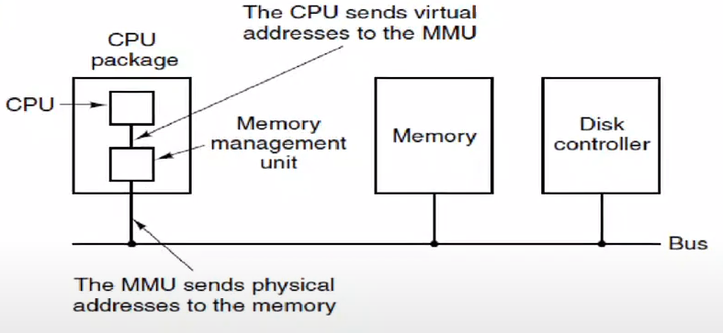

*Figure 3-8. The position and function of the MMU. Here the MMU is shown as being a part of the CPU chip because it commonly is nowadays. However, logically it could be a separate chip and was years ago.*

Everytime I make a memory reference from the CPU instruction, MMU translates the memory address from my virtual address.

Each program has its own address space, which is broken up into chunks called pages

The program-generated addresses are called virtual addresses and form the virtual address space.

The virtual address space consists of fixed-size units called pages. The corresponding units in the physical memory are called page frames.

Page sizes are powers of 2: we will se why.

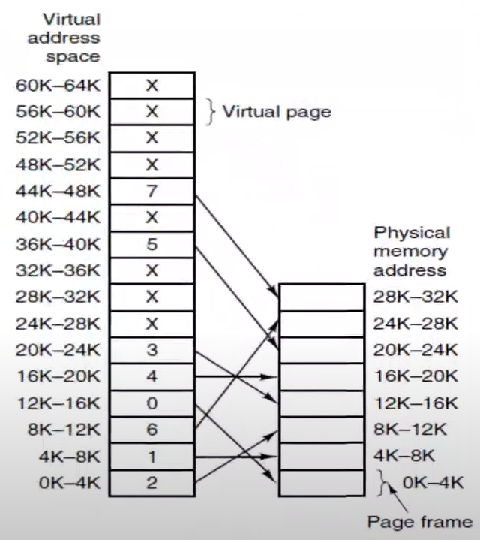The relation between virtual addresses and physical memory addresses is given by the page table. Every page begins on a multiple of 4096 and ends 4095 addresses higher, so 4K-8K really means 4096-8191 and 8K to 12K means 8192-12287.

I have 32 KB of physical memory.

Virtual address space is 64 KB.

Process thinks that it has 64 KB of memory.

We divide our virtual address space into virtual pages. Each of them is 4 KB.

Whenever I need to access sth, for example lets say my process is trying to “JMP 9050”. It is inside third virtual page. In reality, there is a table that says that “This virtual page is in the memory here.”. My virtual page table takes 9050 address, places it into this physical page frame.

There is a transition going on all the time.

Everytime I make a memory reference, MMU gets that virtual address and translates it to physical address during the runtime (execution of instructions). OS is not involved but it programs the MMU, it tells parameters to MMU. It is similar to base and limit registers.

64/4 = 16 🡪 Element number of the array of page table. Each element holds the physical address of the corresponding virtual page. I have 16 virtual pages.

The internal operation of the MMU with 16 4-KB pages.

Present/absent bit keeps track of which pages are physically present in memory.

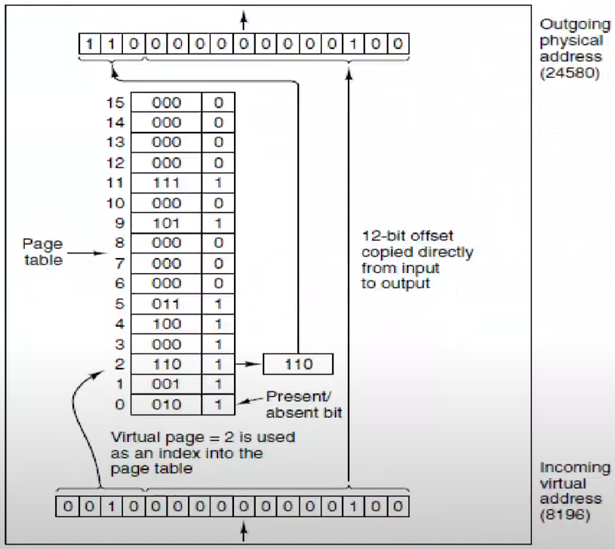

Page table contains addresses of each of the physical pages.

16 bits is my virtual address 🡪 216 = 64 KB of address, memory space. I have to translate it into 15 bit physical address bc my memory is 215 = 32 KB.

I divide my 16 bit virtual address into 4bit-12bit two parts.

There is no modification in 12-bit offset part. That part is address inside the page.

4-bit part is gonna tell me my virtual page number, it is index for my page table. Page number says that “Your physical page number is gonna be 110 that is 6.”.

15 bits for physical address. 🡪 215 that is 32 KB

This is what I do inside MMU. Everytime CPU makes a memory reference, I look up my virtual page number from the page table an I replace that number with the physical page frame and output that 15 bit address to memory. CPU instruction thinks that it is accessing a 64 bit memory but in fact I am accessing 32 KB memory.

This is an associative memory like cache memory. It is very quick. It is not sequential like addition.

Page table is in MMU.

0 for present/absent bit means that page is not available. It is not uploaded in my physical memory (X in the one former ss). It is expected bc my virtual memory is 64 KB, physical memory is 32 KB.

What happens if I try to access sth in X box?

* MMU is gonna tell me that address is not available.
* I may get rid of one of the pages, write it back to disk and get rid of it. Points X to where removed box points.

We didn’t prevent swapping but I don’t need to swap the whole program, I swap parts of it.

Also my program doesn’t have to be kept contiguously on the physical memory.

Also I don’t have to keep all the pages in the physical memory. Most of them can stay on the disk if they are not used.

I don’t have to do compaction bc my process is already divided into parts. Those parts don’t have to be in order. As long as they are in the form of 4K chunks (address space is broken into chunks called pages), they can stay anywhere in the memory. I don’t have to move them around. If I move them around, that’s okay, I just change this page table inside MMU.

Memory protection is there too. I can put read, write, execute permissions, pid, … Whenever somebody accesses it, it can know is it for reading writing execution. Also I can know which process owns this page.

I only keep necessary parts of program in memory. Whenever my program becomes active, it starts using more memory bc it gets more pages from the free page pool. I keep some pages available to load new programs or load parts of the programs very efficiently to the memory.

Program needs 64 KB of memory otherwise it cannot run, that’s why we need bigger virtual address space than physical memory address. Remember principle of locality (working principle of cache):

* Assume I have large program from address 0 to 64. If I am executing instructions around a place, next instruction is gonna be around that place 99% of the time. If you access part of the memory, next time you access part of the memory will be around that part.

So even though you need 64 KB of memory, all you are using it maybe 2 or 3 pages of your memory at the similar time. From time to time maybe you are gonna use some other pages, in that case I am gonna load those pages back to the physical memory from the disk.

So it is okay to keep only part of your program in the physical memory, rest of them can stay on disk. Without swapping much, I can continue.

4KB is the least amount of memory you can use. If you have a process that need only 1 KB of memory, then you have to use your whole page and waste some part of it.

I don’t have external fragmantation with paging. I can use every place for anything.

Internal fragmentation 🡪 If I have 10 KB of memory, first 2 page frames are going to be used but half of the third one is gonna be wasted. This is not avoidable. So we don’t like very large page frames. I prevent this by keeping page size small.

For some server application where you don’t have many clients, you may use big page size.

What is the problem with small page size?

* If I have 4 KB pages, then 12 bit offset is enough for me bc 212 is 4 KB.
* If I have half a KB pages, then 9 bit offset will be enough bc 29 = 512 B.
* Rightmost 9 bit will be my offset, leftmost 7 bit will be my frame number. That means I have to keep 128 elements in page table.
* Page table is very expensive bc it is part of the MMU and MMU is part of the CPU package. Each one box is register.

You have to keep balance. Don’t make page size small or big.

Implementing Virtual Memory

Divide a virtual address A into <V, O>, where V is the virtual page number and 0 is the offset within the page

* Assume A is 16 as former example. We divide it into 2 🡪 4 bit (V) | 12 bit (O)
* It is 12 bc my page size is 212 = 4 KB.
* 4 bit is gonna be used for lookup index.

The MMU maps V into P, the physical page number and produces <P, O>

* P is 3 in former example

In its simplest form, this mapping is done by direct indexing into an MMU register bank M:

A 🡪 <M[V], O> P = M[V]

This scheme can be faster than a base and limit registers; no additions are involved.

Lookup procedure is done by associative memory so it is faster.

Some part of address space is in physical memory and some part is not.

OS only involves when I fill in page table. Somebody has to fill the table and say that these pages are not available (0 present/absent bits).

Is it possible that all present/absent bits are 1 in page table?

* If my virtual address space and physical memory address space is equal or physical address space is larger than virtual address space, then it is possible.
* In that case, why are you using the virtual address space?
* Even physical memory address space is larger, usually our page tables are mostly empty bc I like to keep more than one program in my memory.
  + Lets say I have 128 KB of physical memory but virtual address space is 64 KB.
  + I like to fit 4 programs.
  + There are 4 page tables for 4 processes. So 64*4=256 is needed but I have 128 KB.
  + I cant fit all 4 programs into my physical memory. So some of them will leave out.
  + So tables of some of the processes will be half empty.

Yes, we keep separate page table for each process bc my page table represents my virtual address space. Virtual address space is different for each process.

This is the real part of what makes the context switching expensive. Everytime I do context switch, OS has to overwrite all the data in page table. Save all the data for previous process, load all data for new process from the process table.

Invalidating/revalidating cache, saving/loading registers, saving/loading page table make context switch expensive.

Structure of a Page Table Entry

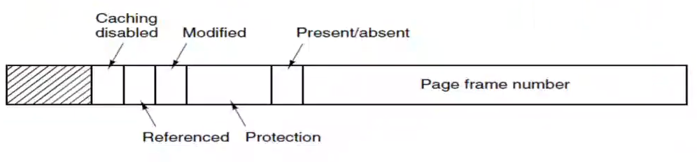



*Figure 3-11. A typical page table entry.*

Some OSs may ignore some of the bits. Hardware wise all OSs use same structure but meaning changes.

If I have k bits in page frame number, I will have 2k possible physical page frames.

Present/absent (or valid/invalid) bit is either 1 or 0. If it is 0, page frame number is junk.

Protection bits 🡪 I can have read-only, writable, executable pages. It depends on what kind of information we have inside protection part.

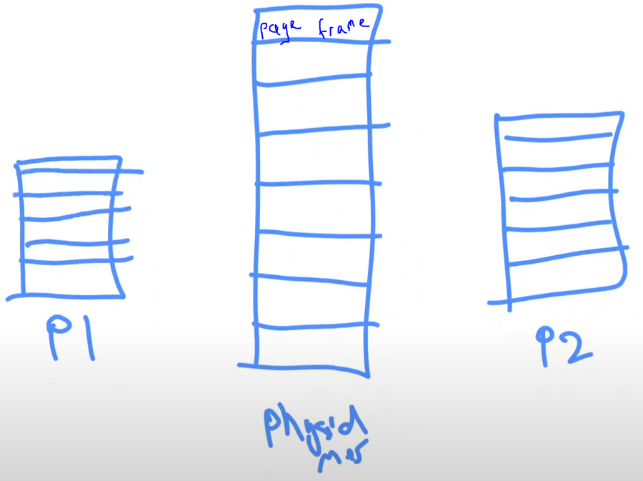I can say P1 and P2 are sharing one page in physical memory.

virtual address space for P1

virtual address space for P2

I can say address number 000 for P1 is address number 0B2A for P2. If P1 owns the page frame (it can read and write), maybe P2 can see that page as a read-only memory.



This is way of sharing pages between the processes. That makes inter-process communication a lot easier. Also this is a lot more efficient.

Whether page is protected properly is satisfied by MMU.

Modified/dirty bit 🡪 Set if the page is written to. If a virtual address says that I am not in the memory (X), it has to be loaded from the disk. I need to do a page replacement if all the physical page frames are filled.

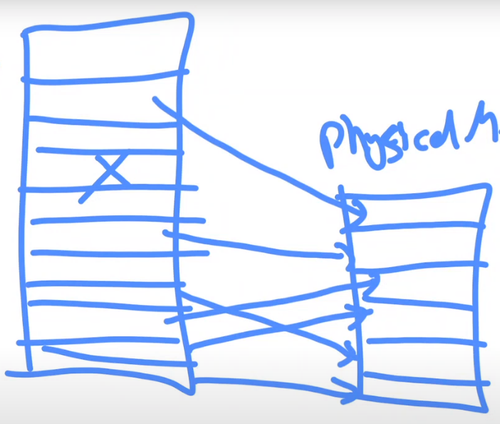Choose a page from physical memory, get rid of it and replace it with new one.



Lets say I have chosen red one. If this page is modified (written over), then I have to write it to the disk before I get rid of it.

I know if a page is modified or not via modified bit.

Modified bit is 1 if page is modified. If it is modified, I have to write it to disk.

Referenced bit 🡪 If I have read the page before, then this bit is set. Modified bit and referenced bit are set by MMU. In memory, there could be pages which are not read at all or not modified. How come they are in memory? Maybe they are automatically loaded by OS at the beginning of process creation.

Caching disabled 🡪 Means that this page should not be kept in the cache. For some performance or algorithmic reasons, I like to keep that page always in the memory. Don’t take it to the cache. Don’t try to make this page a fast page.

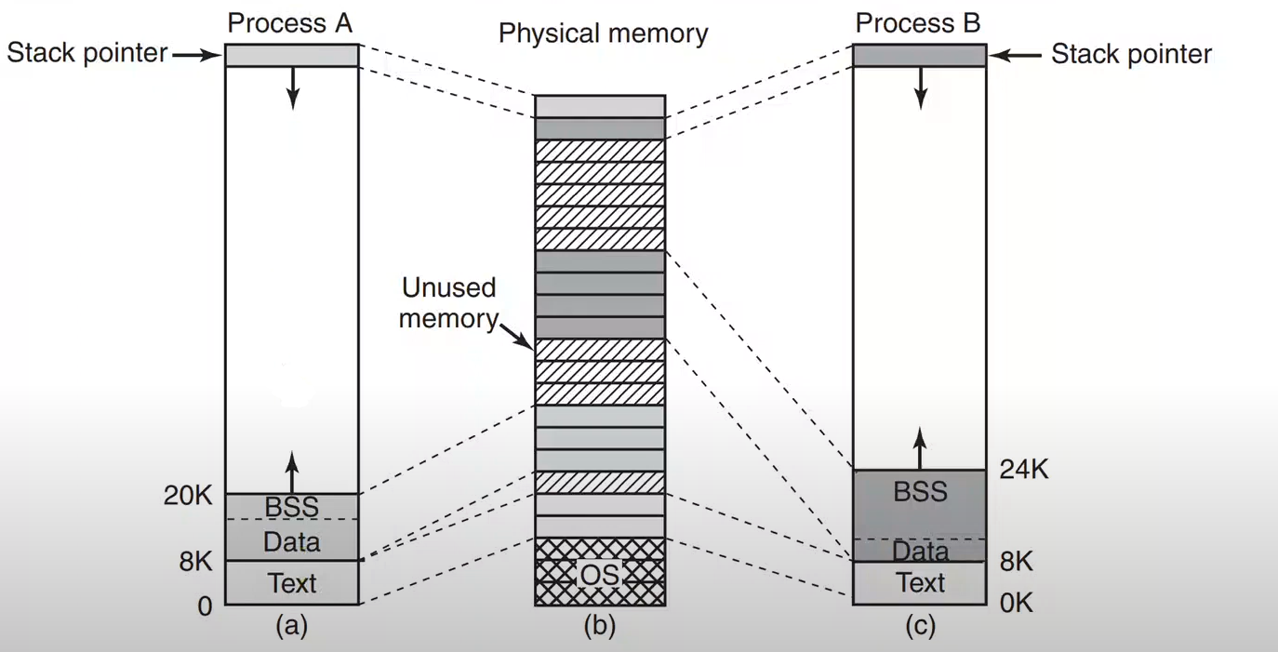

*(a) Process A’s virtual address space (b) Physical memory (c) Process B’s virtual address space*

Too Simple

Earlier times this could work – page sizes were large relative to memory

* Converting a virtual address into physical address is exactly as what we have seen

The PDP-11s on which Unix grew up had only 8 pages of address space – that many registers were affordable

* Virtual address space was just 8 pages.

Modern computers easily have 1 GB (230) of memory and pages of 4 K bytes (212) – or 256 KB (230/212=218=256KB) possible pages. If you multiple it by 4 (assume each page holds 4 byte of data) then you got 1 MB for page table.

* Linux is using 232 = 4 GB of memory space for a standard 32-bit process.
* Usually our pages are 212 = 4 KB each.
* How many entries should I have for a typical Linux process in the page table?
  + 232/212 = 220 entries for each process table.
  + Each table element will contain 22 = 4 bytes of data
  + 220 x 22 = 222 = 4 MB of memory space for page table.
* 4 MB for page table is not realistic bc I can’t fit that kind of data in my MMU. That’s too large.

We need a separate page table for each process – we can’t afford to copy that many MMU registers during process switches

We can’t have that many MMU registers. We keep page table in memory itself. In MMU, we have small page table.

* Unfortunately, I have to repeat this for all the processes. Each process will have 4 MB of page table in the memory.
* I don’t wanna keep all of this stuff in memory.

Today, we have 64 bit computers. If my address space is this (264) big, and if I have 4 KB (212) page entries, I need 252 page table entries 4 bytes each 🡪 254 bytes for page table. There is no way I can fit this in physical memory.

* It is expected virtual memory is larger than physical memory but page table being larger than my physical memory is problematic.
* We have to solve this.

Page Tables in RAM (for 32-bit computers)

First-order solution: put the page table in RAM

Still problematic:

* It’s slow – an extra RAM access for each memory reference
* It’s a lot of RAM for page tables

Transition from virtual address space to physical address space will be too slow. Everytime I make a memory reference, I need to go to memory 2 times.

* I need to keep some part of the page table in RAM, some part of it in MMU registers.

Page tables do live in RAM, but there are optimizations.

Speeding Up Paging

Major issues faced:

* The mapping from virtual address to physical address must be fast.
* If the virtual address space is large, the page table will be large.

Translation Lookaside Buffer

Mappings from virtual address spaces are cached in the Translation Lookaside Buffer (TLB)

The TLB is an associative memory – it maps a value, rather than an index, into another value

When there’s a TLB miss, an old entry is discarded, a memory lookup is done, and the new entry is inserted into the TLB

This works because programs tend to exhibit locality of reference

On many systems, the TLB is managed in hardware; on RISC systems, it is explicitly populated by the OS

* OS is responsible for managing the data kept in the TLB on RISC systems
* RISC says don’t implement anything in hardware. If it can be implemented, implement everything on software. Use the hardware to make more registers, to make more room for CPU memory.

Windows and Linux handle TLB by themselves.

Address translation is done by the MMU, hardware, not by the OS bc OS cant do that in real time bc it is piece of software. If you do translation by software, it becomes 10 times slower.

We keep page table entries in TLB.

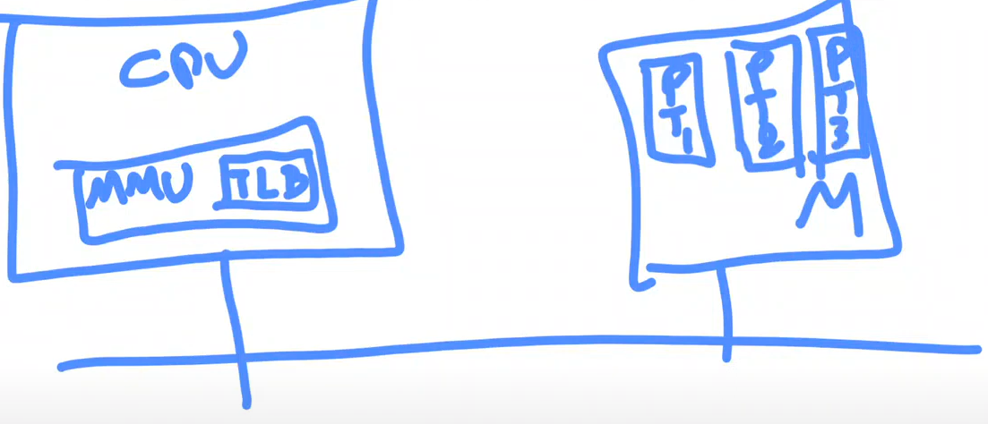

PT: page table, M: memory

TLB is basically cache representation (between page tables in memory and MMU) of page tables.

I have page tables for each process in memory.

TLB keeps frequently used, recently used entries of page tables.

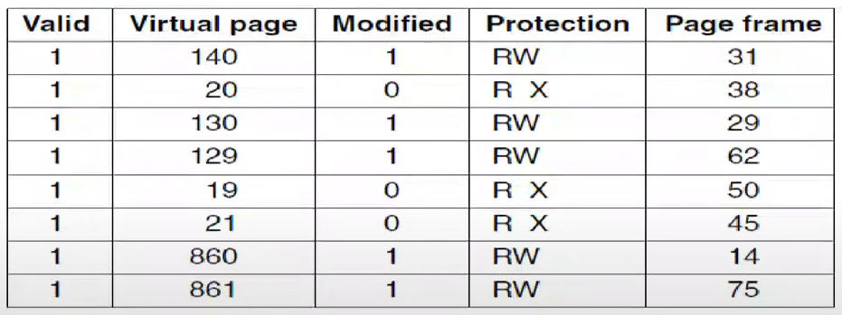

*Figure 3-12. A TLB to speed up paging*

I ask this 🡪 “Do you have virtual page 20?”. 🡪 It is here and corresponding page frame is 38.

“Do you have 128?” 🡪 No. I need to get that page from the memory.

Most of the references will be included in TLB. It is very small so it can sit in MMU.

Because of principle of locality, I say that most of my memory references will be around the same page. If I am running a small loop, that would fit into the same page frame so I will keep referring to same virtual page all the time while that loop is running. I don’t have to go to memory to get the physical addresses.

Page fault 🡪 Page is not in memory, it has to be loaded.

There are different page table for each process. Which process owns 20th page in TLB?

* Only the running process uses the TLB.
* When you do context switch, you have to invalidate your TLB and repopulate it.
* When you switch from one process to another, all the memory references for the new process is gonna be page fault. Everytime I look at the TLB, you are gonna see page is not there. So I need to go to memory and find the page frame number from page table and repopulate TLB.

Why we don’t discuss about how to manage cache between CPU and memory (L1, L2, L3 caches…)?

* It is handled by hardware.
* OS, most of the time, doesn’t know that how much memory is in cache and how much in memory, what is my cache hit rate, what is my replacement algorithms etc.
* ---
* MMU and TLB are handled by software (OS) on most RISC machines.

Software TLB Management

Many RISC machines do nearly all of this page management in software.

A much simpler MMU, which frees up a considerable amount of area on the CPU chip for caches and other features that can improve performance.

* If MMU is very simple, everything is handled by software. That means I can reserve hardware resources for more larger TLB space or cache space or other hardware stuff. That’s the idea of RISC.

***What happens when I do memory reference? (MOV R1, F2B722)***

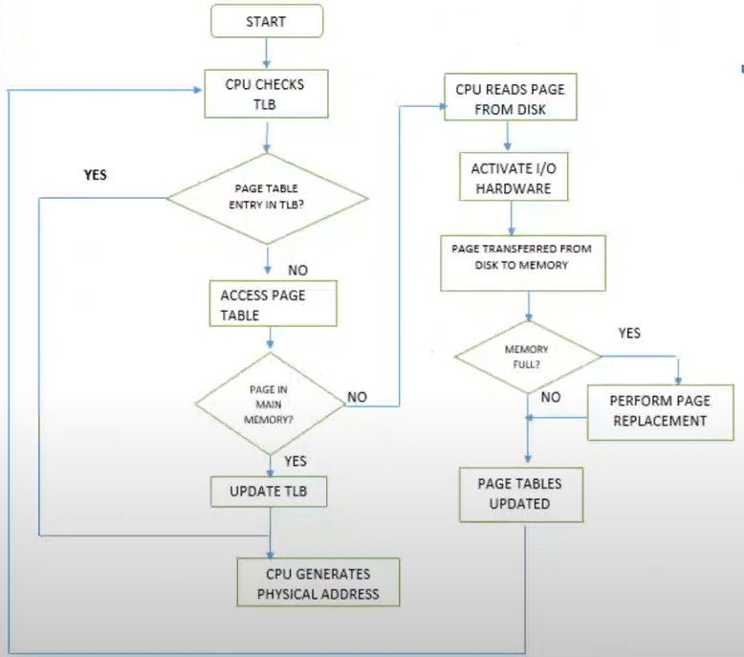

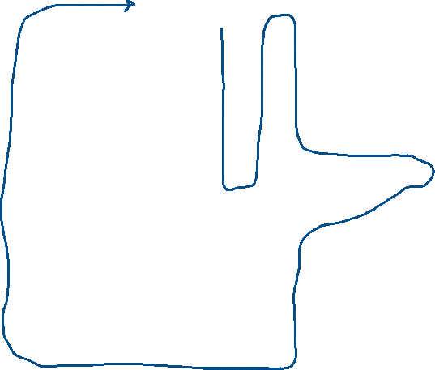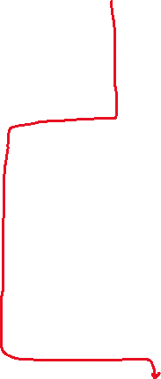

memory reference

done by hw

F2B722 is in my virtual address space but is it in memory?

Check TLB 🡪 check page frame number which is beginning of F2B722.

If it is in TLB, physical address is generated then I know the physical page frame. I can combine it with the offset and I can produce physical address space. I can do this in single clock cycle. This is the best path.

If it is not in TLB, I need to access page table which is in main memory. If page is inside the memory, update TLB, choose one of the elements and take out from TLB. Then replace it with new page number. Removed one has to be not recently used one. This path is not that bad. Only 1 memory reference.

Worst case is page is also not in the memory. I have to go to disk. I know where that page is on the disk. I will ask to disk. That will cause a system call. If memory is full, I have no physical page available. Then I need to do page replacement with non-used physical page. Now my page is in the memory. I update my page table. This blue line includes page fault.

Typical TLB

* These are typical performance levels of a TLB:[17]
* ---
* size: 212 – 12 bits – 4096 entries
* hit time: 0.5-1 clock cycle
* miss penalty: 10-100 clock cycles (go to memory)
* miss rate: 0.01-1% (20-40% for sparse/graph applications)
* ---
* If a TLB hit takes 1 clock cycle, a miss takes 30 clock cycles, and the miss rate is 1%, the effective memory cycle rate is an average of
  + (1+30) x 0.99 + (1 + 30 + 30) x 0.01 = 31.30
  + (31.30 clock cycles per memory access)
  + ---
  + (1+30) 🡪 Best path. 1 clock cycle for TLB hit. When I generate physical address, I go to memory to do what I need to do. That’s where 30 comes from.

OS keeps some part of the memory empty (called demand paging – we are gonna see). I am gonna keep some pages always available. Even though I need lots of pages, I cannot fit all of these programs in my memory. I am gonna keep most of them on the disk and I will try to make sure that at least 10-15% of the memory is available. That’s what makes our memory reference algorithm fast bc memory is not full. You don’t want to do page replacement much. Just load the page to empty pages.

How do I keep these many pages available?

* Windows is writing unused pages to the disk if they are dirty in the background.
* If they are not dirty, then you don’t do much.

A soft miss occurs when the page referenced is not in the TLB, but is in memory. 🡪 a few nanoseconds

A hard miss occurs when the page itself is not in memory.

A minor page fault: the page may actually be in memory, but not in this process’ page table, the page may have been brought in from disk by another process.

* Page is not in TLB, not in my page table but it is in memory. That means some other process loaded the page into memory but I don’t have a pointer to it. My page table doesn’t contain. All I do is linking my page table entry with page in memory. I don’t have to load anything from disk.

A major page fault: if the page needs to be brought in from disk. 🡪 milliseconds

Segmentation fault: the program simply accessed an invalid address.

* You are accessing memory location that doesn’t belong to you or,
* You are trying to write to a memory location that is read-only or,
* You are trying to access a memory location that is not executable.
* ---
* Best way to get the segmentation fault is:
  + int* p = nullptr;
  + *p = 12;
* nullptr is 0. In our process structure, we keep the code at address 0 which is executable. If you try to write to this executable stuff, you are gonna get segmentation fault.

Page tables are still very large. They are like 4 MB, 10 MB, 12 MB… of space. If I have 100 of them for 100 processes, that makes 400 MB. I don’t want to keep them in my memory. That’s too much space.

Since page tables are process related data, usually you keep this kind of data in your process table. Keeping 4 MB of data in your process table requires lots of space in your kernel space. That’s not good.

Multilevel Page Tables

Another problem is how to deal with very large virtual address spaces comes with very large page tables.

The secret to the multilevel page table method is to avoid keeping all the page tables in memory all the time.

In Fig. 3-13 (a) we have a 32-bit virtual address that is partitioned into a 10-bit PT1 field, a 10-bit PT2 field, and a 12-bit offset field.

Since offsets are 12 bits, pages are 4 KB, and there are a total of 220 of them.

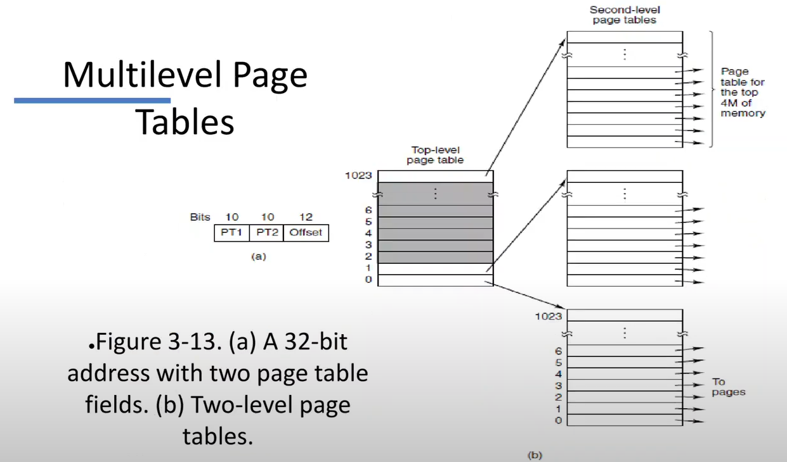



Lets say I have 32-bit computer. 232 = 4 GB of addressable space.

(a) is how I structure my virtual address. 12-bit offset, 10-bit virtual page number, another 10-bit virtual page number.

PT1 🡪 10-bit page table address. Get this 10-bit, find corresponding element in top-level page table, let’s say I found red one, follow this link and this link will give you another page table. Use the second index PT2 to find corresponding element in that page table. What you get is your final page frame number.

If I don’t have multilevel page tables, this (a) would have 220 elements that is 1 mega elements in my page table, in my memory.

Now I keep 1000 elements in top level, 1000 elements in secondary level. If I am not using all the others in secondary level, I can keep them on my disk. Only ones that I used are in memory. I am only keeping 2000 elements in memory.

I am paging the page table.

I am keeping most of the page tables on disk, not on memory.

Intel’s 32 bit 80386 processor (in 1985) was able to address up to 4-GB of memory, using a 2-level page table (4-KB page frames). 210 x 210 x 212 = 232 (It can address 232)

10 years later, the Pentium Pro, page map level 4, 512 entries in all tables

29 x 29 x 29 x 29 x 212 = 248 memory (addressable virtual address space for each process)

512 elements in table, for each of them 512 elements, for each of them 512 elements, for each of them 512 elements. That is number of page table entries you have. Most of the time you keep 99% of these in your disk. Not in the main memory.

Inverted Page Tables

In this design, there is 1 entry per page frame in real memory, rather than 1 entry per page of virtual address space.

Inverted page tables save lots of space but virtual-to-physical translation becomes much harder.

When process n references virtual page p, the hardware can no longer find the physical page by using p as an index into the page table.

Instead, it must search the entire inverted page table for an entry (n, p).

Solution: Use TLB and hash tables.

Let’s say I have a virtual address space of 16 bits 🡪 216 is my address space

Page size 🡪 4 KB = 212

216/212 = 24 elements in page table

My physical memory is 🡪 214

214/212 = 22 pages in physical memory

When I need to access some part of memory, I need to look it up from page table and follow the link to memory.

INVERTED PAGE TABLE says that most of the table virtual address space will be empty. Only 4 elements can live in there.

Why don’t we keep a page table with only 4 elements which is the size of physical memory.

First 4 bits of my virtual address 🡪 virtual bits (V). 4 bits means 24=16. I need 16 elements but I don’t have 16 elements in table. I take V and use hashing function (H) to map it to 4 numbers (IPN: Inverted Page Number).

H(V) = V % 4 🡪 You get inverted page table number. Then you get your frame number.

Problem is 🡪 2 and 14 are pointing to same place (2). This is collision. You can put linked list for each page. It requires you to make search in linked list but it can be done in O(1).

Inverted page table is good solution to keep a fraction of memory required for the page table.

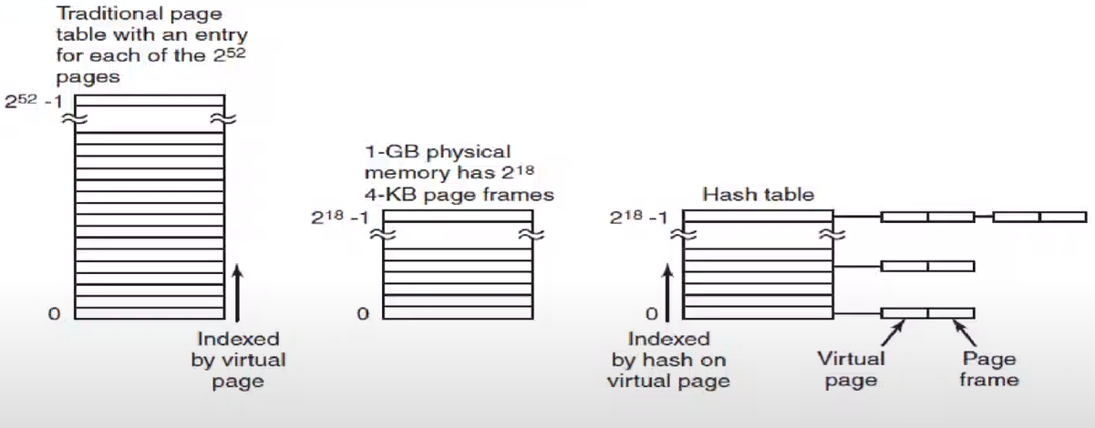

*Figure 3-14. Comparison of a traditional page table with an inverted page table.*

Let’s say you have 64 bit computer. You are using whole 64-bit for virtual memory addressing.

Page size is 4 KB = 212. That means I need 252 page table entries. You can’t fit this into any memory.

If my physical memory is 1 GB = 230 bytes, with 4 KB page frames it is gonna be 218 entries in inverted page table.

Windows and Linux don’t use this, they use multilevel page tables.

*Example:*

I have 16 bit of virtual address space = 216.

I have 15 bit of physical address space = 215.

216/212=24 = 16 virtual pages

With inverted page table (IPT) I keep 8 elements which is same as physical memory.

Translation from 16 bit to 15 bit:

* Get leftmost 4 virtual bits (V)
* Rightmost 12-bit is offset again
* Assume V is 1010 = 10
* H(10) = 10 % 8 = 2
* 2 is position in IPT. I have a linked list.
* Assume there are 2 elements in list. First one’s V is 2, second one’s V is 10 which is our case.

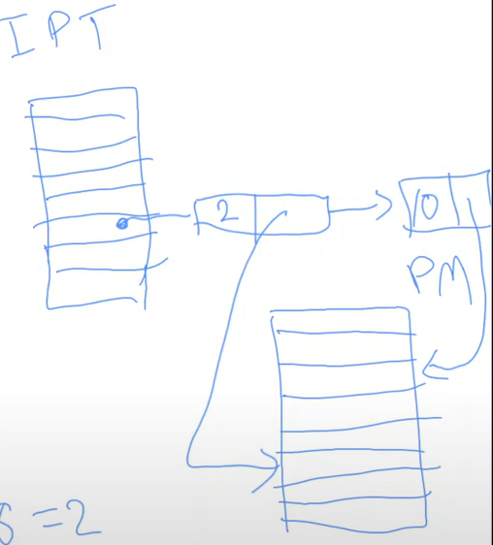PM: Physical memory

Run simulations and decide you use multilevel or inverted page tables. Look number of memory accesses, memory that you use, CPU time…

Going from regular page table to multilevel page table is easier than going to inverted page table.

Which part of the virtual memory I am gonna keep in disk? I need to get some part of virtual memory from disk sometimes. If my memory is full, I should replace one of the page frames. Page replacement algorithm makes this decision. It is like scheduling.

Page Replacement Algorithms

Similar method with CPU cache, web server cache

* **Optimal algorithm**
  + This one is not implementable, it is theoretical.
  + This algorithm needs to see the future. After that it says if you replace this, it’ll be better.
  + This algorithm is good for comparing your algorithm with it.
  + Your algorithm cannot do better than this algorithm. If you are doing similar to it, it is good.
* **Not recently used algorithm**
* **First-in, first-out (FIFO) algorithm**
* **Second-chance algorithm**
* **Clock algorithm**
* **Least recently used (LRU) algorithm**
* **Working set algorithm**
* **WSClock algorithm**

Not recently used, FIFO, LRU are for educational purposes. They are gonna help us understand how they work.

Best algorithms are WORKING SET and WSCLOCK. Linux and Windows use them for page replacement.

***Constraints:***

* Must be efficient – many paging decisions take place
  + Page replacement will occur frequently.
* Must approximate the correct answer – to optimal algorithm
* Must be implementable on real hardware
  + If we get more hardware help, it would be good. We don’t have that kinda help always.
* Usually, must work well on multitasking systems

***Tools:***

* The OS has a few tools available to it
* The referenced bit – this page has been used recently
* The modified bit – discarding this page will be more expensive
* Clock interrupts
  + Everytime it happens, I can do some page table management.
* Page fault interrupts
  + Happens when there is unmapped or non-existent page
  + Initiated by hardware. MMU says I don’t have this page so it causes interrupt.
  + OS has to handle it.
* Advice from the application
  + Application may say “I need this kind of page replacement algorithm. I am gonna keep these pages in memory always bc these are important but others not that important.”.

Referenced bit and modified bit are done by hardware (MMU). Whenever you access the page table in your MMU, if you are writing to some location, corresponding page table entry of modified bit will be set to 1. Same for referencing.

We try to optimize “how many times we need to replace a page” with page replacement algorithms. Dropping # of page replacement to 0 is **not possible** bc virtual memory space is larger than the physical address space. Best possible one is optimal algorithm.

At every memory reference, MMU does the transition from virtual address space to physical address space. When MMU realizes that there is no corresponding item in page table in MMU so it cannot translate it so it causes a page fault interrupt.

All tools are available to OS.

**Optimal Algorithm**

Simple but impossible to implement

The optimal page replacement algorithm says that the page that will not be referenced longest should be replaced.

We can run algorithms on simulators, we would know the longest unreferences pages for the 2nd run.

In this way, it is possible to compare the performance of realizable algorithms with the best possible one.

Claims to know the future.

This algorithm says:

* I have run this program before under same conditions.
* I know which pages it requires, which pages it is not gonna use etc.

So we can do best decision to replace pages.

You are making decision after the things happened.

**Not Recently Used Algorithm (NRU)**

At page fault, system inspects pages

Categories of pages based on the current values of their R and M bits in order:

* Class 0: not referenced, not modified. (0, 0)
* Class 1: not referenced, modified. (0, 1)
* Class 2: referenced, not modified. (1, 0)
* Class 3: referenced, modified. (1, 1)

Class 0 🡪 nobody is using

Always replace class 0. If there is no class 0, then class 1, then class 2, then class 3.

Replacing a modified page is more expensive bc it is needed to be written to disk. You can just ignore class 0, replacing is cheap. Also class 2. Replacing it is cheap bc I don’t need to write it to disk as class 0.

Class 1 and 3 have to be written to disk before replacement. They are more expensive to replace.

How come a page is modified but not referenced (Class 1)?

How come a page is not referenced and not modified (Class 0)? If nobody has used it and nobody has modified it, how come it is in memory? The reason why a page is in memory bc somebody has accessed it either modified it or read it.

Algorithm is this:

* At process start time, reset all R and M bits
* On clock interrupts (500 times a second maybe), clear R bits
  + When clock interrupt happens, you scan your page table and make all reference bits 0
  + Between the clock interrupts, your programs will run, they will reference the pages and some of them will become 1 again.
  + That’s the reason why we have 0 for reference bit.
  + A page that is not referenced in last clock cycle will become 0. Doesn’t matter if it was referenced before. I just lost it.
  + Why don’t we reset M bits along with R bits?
    - Because M bit means that that page is modified.
    - When I replace that page, I can’t just ignore it. I need to write it back to disk.
    - I cannot reset that bit to 0.
    - ---
    - Why Class 1 has more priority than Class 2 for replacing?
      * Page may have been modified maybe 5 clock cycles ago. Since it was not reset, it keeps its value of 1 all the time until it is replaced.
      * Class 1, though, is referenced in the last clock cycle. So this may be more recently used than Class 2.
      * SO IF A PAGE IS REFERENCED, IT IS DEFINITELY REFERENCED IN LAST CLOCK CYCLE. IF A PAGE IS MODIFIED, WE CANNOT BE SURE THAT IT IS MODIFIED IN LAST CLOCK CYCLE.
* Classify pages by M and R:
  + 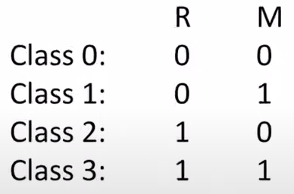
* On page fault, discard a random page from the lowest class

NRU algorithm uses referenced bit, modified bit, clock interrupts, and page fault interrupts in the tools that we defined.

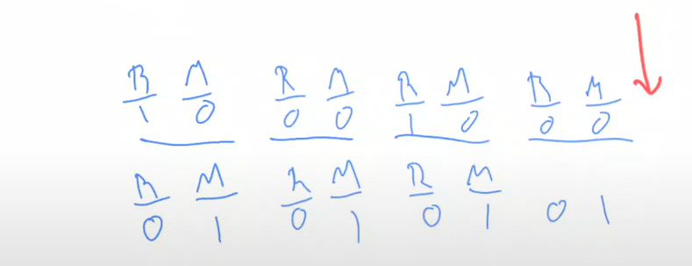

clock cycle

clock cycle

clock cycle

clock cycle

At the end, we replace upper one bc it is Class 0. Bottom one is Class 1.

Lower one is not referenced and not modified for last 4 clock cycles. It should be replaced.

I keep resetting the R bit over and over again and I may end up in a situation like this.

OS checks pages one by one to find best class to replace.

*Notes:*

* *We spend less than 1% of CPU time for interrupts.*
* *If you have more than 1 threads waiting in processor then things are really busy.*
* *There is cache between memory and disk.*
* *Committed bytes: dirty bites of memory. They need to be written to disk.*
* *GUI requires lots of system calls and CPU time.*
* *Transition fault: soft miss*
* *When you copy process with fork, Windows and Linux don’t really copy stuff. They just share pages bc processes are using exactly the same thing why copy it. If one of them writes to one of the pages, then that has to be copied. Write copies means this. If you do process related stuff, write copies per second gets high.*
* *Virtual address space for Google Chrome can be 3 terabytes. Chrome thinks it is using 3 TB of space. In fact, it is using only hundred of MB.*

Resetting R and M:

* Why do we reset R on clock interrupts?
  + We want to know if a page has been used recently.
* Why not reset M?
  + M cannot be reset until the page has been written out to disk; an old copy won’t be sufficient.

***Properties of NRU:***

* Bias towards discarding unmodified pages
* But – better to discard a modified page that has not been used recently than one that is in use
* Simple algorithm; may give adequate performance on some systems
* Primarily useful for teaching, nobody uses it

***What’s interesting about NRU?***

* It has the essential properties of any page replacement algorithm
* It looks for a (relatively) idle page
* It handles modified pages, but is biased against using them
* It is reasonably efficient
  + You just check R and M bits
  + During the clock interrupts, you go over all of your page table entries and make their R bits 0

Page replacement doesn’t happen when page fault occurs.

When page fault occurs, there is always free page available because some part of the memory is idle on purpose, you just use that one.

When do we do page replacement 🡪 there is a pager daemon somewhere, it runs from time to time. It says “Nobody is using these pages, I am gonna write them to disk if they are modified. Otherwise I am gonna discard them.”.

SO page replacement happens before page faults are happening.

If during the page fault handling, if there is no page to replace, then we are in bad situation. All the memory is used up.

**First In, First Out (FIFO)**

Nobody uses this too

Forget about R and M

When a page frame is needed, discard the oldest page

Of course, the oldest page may still be busy, so it will come right back in

FIFO is rarely used in this form:



0, 3, 7, … 🡪 times

**Second Chance FIFO**

I am gonna change oldest that is not referenced.

Similar to pure FIFO, but the R bit is checked

If R is set on an old page, clear the R bit but move it to the just-loaded end of the queue

Approximates somehow LRU (least recently used) behavior

* Note the problem: it doesn’t know if a page has been used recently or not
* It only approximates that if page faults are frequent
* We only know R bit is set whenever the memory is referenced, we don’t know when it was set. I don’t know how recent they are used.

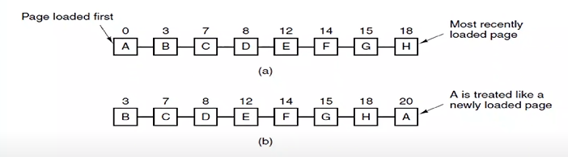

*Figure 3-15. Operation of second chance.*

*(a) Pages sorted in FIFO order.*

*(b) Page list if a page fault occurs at time 20 and A has its R bit set.*

*The numbers above the pages are their load times.*

As soon as I find an old page with R bit 0, then I am gonna replace it.

If all of the pages’ R bits are 1, that means I keep using them all the time. Then this become regular FIFO bc we are replacing the oldest one after put them to the end one by one (at the end original queue is formed).

Loaded pages are ordered in a FIFO list: “oldest” page first in list

When oldest page selected for replacement, the reference bit is inspected

* If value is 0: replace page
* If value is 1: page gets a “second chance”:
  + Clear reference bit, set to 0
  + Move page to tail of FIFO list
  + Check next-oldest page

A page given a second chance will move to the tail of the FIFO queue and becomes the youngest page

Worst case:

* All reference bits = 1, degenerates into pure FIFO

**The Clock Algorithm**

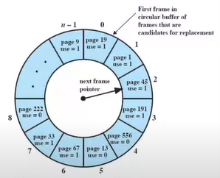FIFO can be implemented with a circular linked list; the list head is changed, rather than moving the page table entry 🡪 the clock algorithm

The set of frames is considered as laid out like a circular buffer

* contains a FIFO list of pages
* can be circulated in a round-robin fashion

Each page has a reference bit

* when a page is first referenced (a page fault that leads to its load), the use bit of the frame is set to 1

Each subsequent reference to this page again sets this bit to 1

Advance pointer to next one if current one has R bit of 1 and make this bit 0.

***Clock policy***

Finding a page to replace

* The “next frame pointer” advances from frame to frame in this circular “frame buffer”
* As long as the “next frame pointer” encounters a page in a the frame with the R bit set to 1, it is set it to 0 and moves on – it gives the page a second chance
* The first page encountered with R = 0 is replaced
* Page is replaced, pointer is advanced to next page

This one doesn’t know about who was referenced least recently.

I wish instead of having R and M bits, I have R/M time to keep time of last reference modification happened. Bigger that time means more recent R/M.

I can now replace the least recently used one.

Who writes this times? MMU is not very complicated to do this. OS runs when there is an interrupt.

**Least Recently Used (LRU)**

Assumption: a page that hasn’t been used recently is unlikely to be used soon

But – how can this be implemented?

More precisely, what data structure do we use to track this?

LRU algorithms cannot be implemented bc we don’t have enough hardware support.

***Hardware-Assisted LRU***

Have a 64-bit instruction counter

* At the boot up, this is 0.
* Everytime I execute an instruction, I increase this counter.

On each memory reference, store the counter in a per-page frame field

On a page fault, scan the page table for the lowest value

Note: this is in the # of page frames

Has to keep all counters in MMU bc it has to update that every memory reference.

Every page table entry has to be more complicated to hold 64-bit number. That makes MMU very expensive.

***Software-Simulated LRU***

No support from hardware. I don’t have any place to keep all those counters in MMU. I keep them in memory as a table and update them during the clock interrupts.

Have an array of counters, one per page – each page has a counter

* I am not gonna increment those counters at every memory reference
* I am gonna increment those counters at every clock interrupt

At each clock tick, add the value of R to the counter

Implements NFU – Not Frequently Used

Problem: never forgets

* If I stop using a page that is used many times before, it stays that way.

I don’t have to keep counters of pages in MMU. I can **keep in my memory**. During the clock interrupt, I am working on this data structure.

It is counting how many times I am referencing a page – kind of how frequently I am using a page.

Most frequently used ones have large counters.

This is not LRU, it is how frequently used.

***NFU with Aging***

Shift each counter right (i.e., divide by 2) before each addition

Add R bit to the high-order bit

Recent references have more weight

Pages referenced this clock tick and previous clock ticks are more important than those referenced only this time

Note: every clock tick the R bit is updated

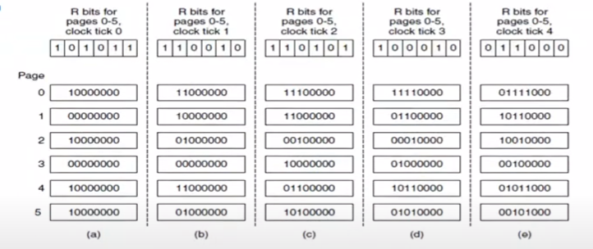



*Figure 3-17. The aging algorithm simulates LRU in software*

*Shown are 6 pages for 5 clock ticks*

*The 5 clock ticks are represented by (a) to (e)*

I am giving more weight to the recent references and I am decreasing the effect of the older references.

At the end (e), you should replace the 4th page. Most recent and most frequently used is 2nd one.

This is not LRU, this is NFU with aging. We are measuring the frequency of the page references but we take the effect of aging into the picture.

I keep counters in memory, in OS’s kernel area and update them during the clock interrupts. Counters are page table sized array of numbers. As an OS, everytime clock interrupt happens, I check the R bits of all the pages one by one and update all these counter values – frequently used values.

Hardware assisted LRU doing its thing millions of times more than what I do with software-simulated LRU. Software simulation is only done during the clock interrupts.

Software simulated LRU is not gonna be as good as hardware assisted LRU.

Remember constraint 3 🡪 Must be implementable on real hardware. Hardware assisted LRU is too expensive for hardware. So it is not efficient.

Efficiency x System cost x Optimality 🡪 we are making compromise between them

ALL THE ALGORITHMS WE HAVE SEEN SO FAR ASSUME THAT WE ARE RUNNING ONLY A SINGLE PROCESS.

But we have multiple processes. Whenever I do page replacement, I should consider different process behaviours.

**Working Set**

Frame Allocation to Processes:

* Demand-paging will allocate frames as necessary
  + Whenever I need a new page, those frames are allocated
* When the free-frame list is exhausted, a page replacement algorithm will choose a page to be replaced
  + If I don’t have any free page, I need to replace a page

Thrashing:

* Thrashing is a situation where a process is repeatedly page faulting
  + The process does not have enough frames to support the set of pages needed for fully executing an instruction
  + It may have to replace a page that itself or another process may need again immediately.
* A process is thrashing if it is spending more time on paging than execution
  + program cannot continue bc it needs a new page
  + then you replace your old page but I need old page too
  + so there is page replacement over and over again

The Working Set:

* At any time, a program is only using a small fraction of its pages (locality of reference) in memory
  + I don’t need all of my program (data and instructions) in my memory all the time.
  + We need to know that fraction.
* The set of pages in use at the moment is the working set
  + If I keep my working set in memory, then I should be fine.
* At time t, the working set w(k, t) is the most recently referenced pages for the last k references
* Note that w is monotonically increasing as a function of k and it asymptotically approaches the total program size
* A program needs to have its working set in memory
* If there isn’t enough memory to hold the entire working set, the program will trash (results in uresponsiveness.).

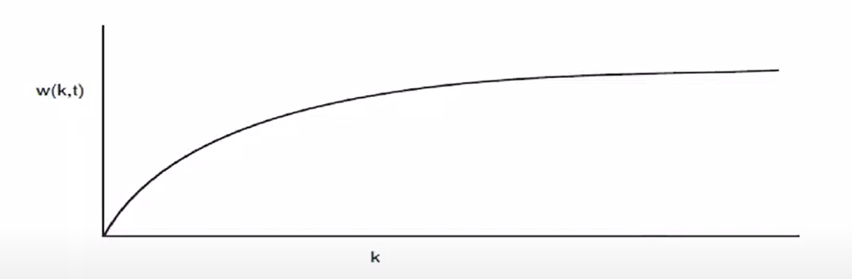

*Figure 3-18. The working set is the set of pages used by the k most recent memory references.*

*The function w(k, t) is the size of the working set at time t.*

w(k, t) 🡪 at time t, it is the # of pages for most recent k memory references

Function asymptotically gets close to a number. That is the total of pages I referenced for the whole lifetime of the process. I don’t have to keep that many number of pages in my memory.

If I keep pages that I needed for last 2 seconds, then it should be enough. This 2 seconds can be 2-3 seconds as long as I use a good enough number most of the my working set should be in the memory.

If there is no enough space for memory to hold large part of working set, program will thrash. It will keep replacing the pages over and over again.

We are gonna modify algorithms in a way that I am gonna measure my working set and I like to keep my working set in the memory.

I may have min and max size as shown with 2 lines. My working set is gonna be between these 2. Every process starts with same min and max but these can change over time.

***Using the Working Set***

Before running a process, make sure that the working set is in memory

Because w is asymptotic, the exact choice of k isn’t critical, as long as it’s large enough

The trick is to determine the working set

***Approximating the Working Set***

Ideally, we would track the last memory references

* like hardware assisted LRU, we need lots of hardware support

Instead, we track pages referenced during the last seconds

For each page, keep a virtual clock field

At each tick (clock interrupt), update the clock field if R is set

* It is very similar to NFU with aging

Pages not referenced during the last seconds may be discarded

* I kinda know how recently I have accessed that page

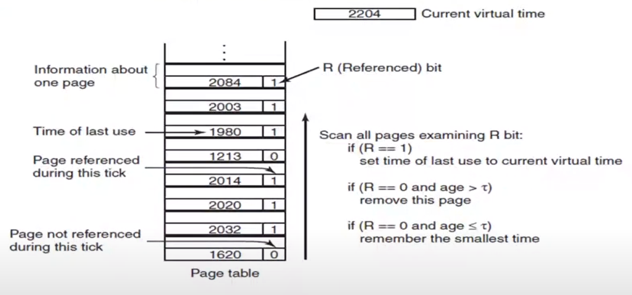

*Figure 3-19. The working set algorithm.*

Virtual time 🡪 I keep incrementing at every clock interrupt

Page table shown is in memory, not in MMU.

For all the entries that has R = 1, I update the time of last use.

Whenever I need to replace a page, I run the algorithm at the right of the figure 3-19.

$τ$ is threshold value. 2 seconds, 3 seconds, whatever…

Age is “current virtual time – time of last use”.

Working set algorithm is implemented using the clock.

**WSClock – Working Set Clock**

Use the working set concept; use the clock algorithm’s data structure

Have a circular linked list of page frames

At each page fault, check the page R and Time pointed by the clock hand; if is R=1, the page is current and can’t be discarded; advance the clock hand

If R is 0, check the age T. If old enough, the page can be reused

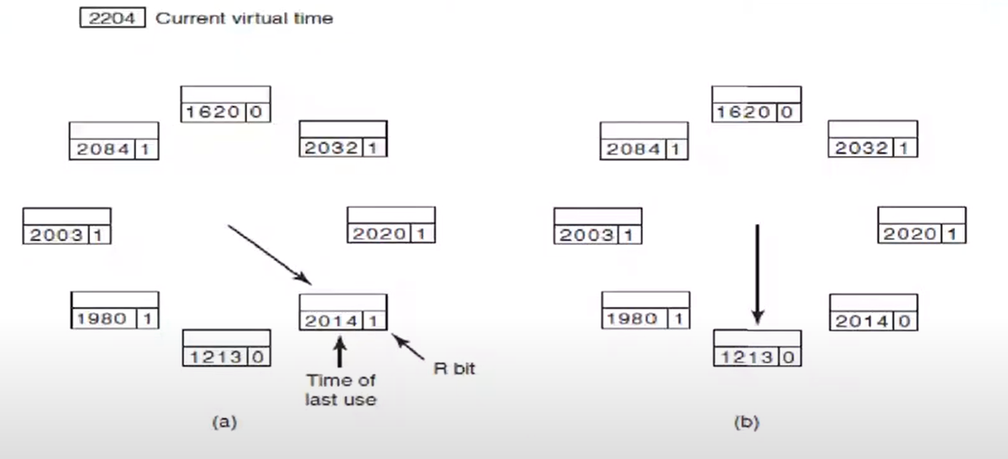

2204



*Figure 3-20. Operation of the WSClock algorithm*

*(a) and (b) give an example of what happens when R = 1*

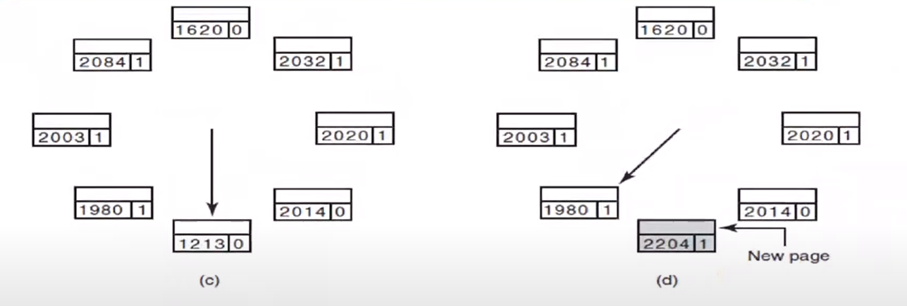

*Figure 3-20. Operation of the WSClock algorithm*

*(c) and (d) give an example of R = 0*

If clock hand turns around and comes back, I have to replace sth in my working set unfortunately. That will cause trashing. That’s how I detect trashing for my process.

Windows and Linux use this algorithm for page replacement.

Working set size can change during execution of program.

Working set is different for each program.

I handle virtual memory by looking at how the applications behave. I don’t keep one global LRU algorithm. I use algorithms that are keeping data specific for each process.

When I close a program, working set does not decrease because OS thinks I can use it again.

***Dealing with Modified Pages***

If W is 0, the page frame exists on disk and can be reused immediately

If W is 1, schedule it to be written to disk and keep scanning – you might find a clean page

***What happens if the clock hand circles?***

If some writes have been scheduled, keep looking; a write will complete eventually

If no writes have been scheduled, all pages are in the working set; pick a random clean page to reuse

SUMMARY OF PAGE REPLACEMENT ALGORITHMS

NRU is never actually used.

NRU doesn’t mean we are replacing a page that is not in working set. Page may not be NRU, but it might be still in the working set.

Plain FIFO works poorly (oldest doesn’t mean it is a bad page); second chance FIFO works reasonably well

NFU with aging is a good choice

WSClock is efficient in terms of data structures used and gives good results

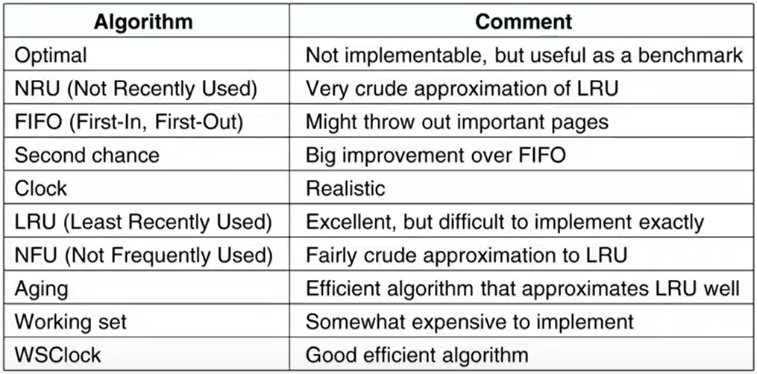

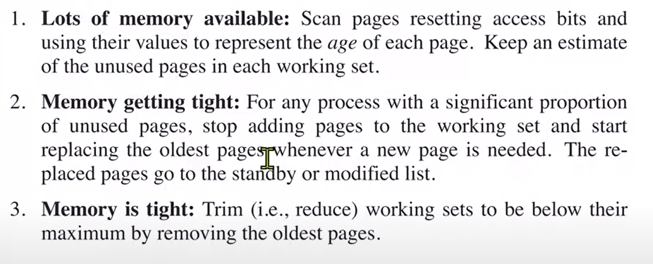

If memory is available, we don’t do any page replacement.

**DESIGN ISSUES OF VIRTUAL MEMORY**

Local versus Global Allocation

When process A has a page fault, where does the new page frame come from?

More precisely, is one of A’s pages reclaimed, or can a page frame be taken from another process?

If another process, do we bias the selection in any fashion?

If page replacement affects only the current process, we have a local policy; if we look at all processes, we have a global allocation policy

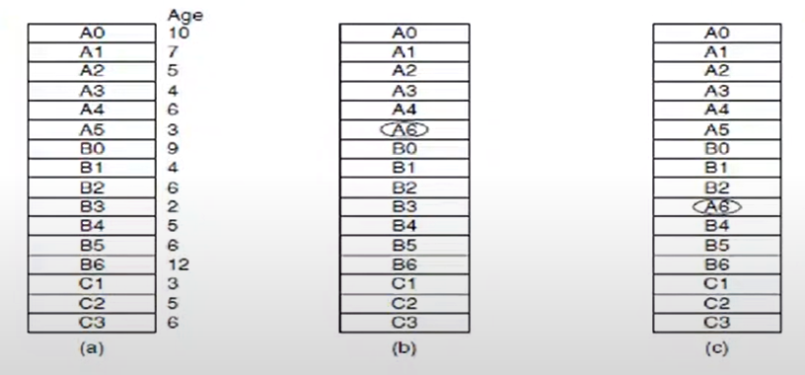

*Figure 3-22. Local vs global page replacement – physical memories and pages*

*(a) original configuration*

*(b) local page replacement*

*(c) global page replacement*

Lets say process A needs a new page number 6. Should I replace one of the pages of A or any of all pages. 🡪 QUESTION OF GLOBAL VS LOCAL ALLOCATION

If I replace local only, process sizes will stay the same. That’s not good bc processes are dynamic. They get larger and smaller.

***Choosing***

Global policies tend to work better.

If you use a local policy and the working set grows, you can get thrashing.

* Even though you have pages available in other processes, you keep replacing your pages over and over again.

Similarly, if the working set shrinks, you waste memory

With a global policy, though, you need to decide how much memory to allocate to each process

***Memory Requirements Change***

Processes grow and shrink

Working sets grow and shrink

Allocations must be changed over time

Monitor the page fault frequency (PFF) for each process

A process with a high PFF gets a larger allocation; a process with a small PFF gets a smaller allocation

If I am thrashing, I am using most of my system time doing paging instead of executing stuff.

If you have a process with high PFF (thrashing – many page faults),

* I don’t have enough pages to increase the working set. Why it is doing high PFF is its working set is not fitable in my memory.
* You need to terminate other processes so that you have enough memory or better than the terminate, I should write all process to the disk and I will tell to process that “I will suspend you for a while. You are not gonna run.”. I will let the other process run first. Then I will load back suspended process from disk when other process finished.

***Local vs. Global Allocation Policies***

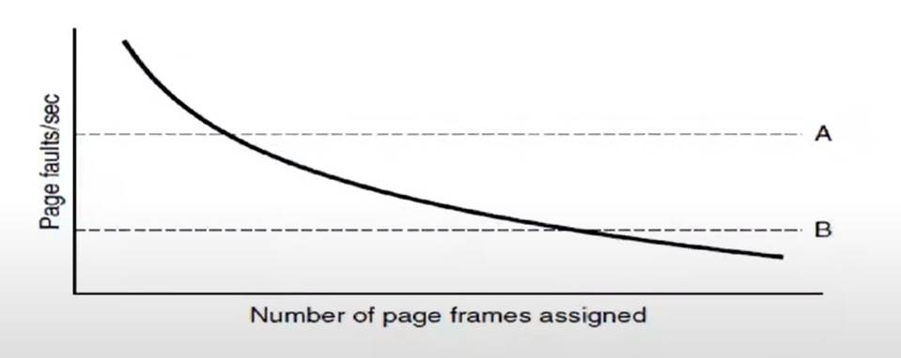

*Figure 3-23. Page fault rate as a function of the # of page frames assigned.*

If I have page fault between A and B, I am fine. It is my optimal area.

If I am above A, then too much page faults. I am thrashing. I should suspend this process and keep it from running.

If I am below B, I am having very low page faults. This is also not good bc you may be wasting memory. If all of my processes are below B, then I can waste memory, I am okay. Otherwise, I should decrease my working set size for processes below B.

A and B values might be different for different programs.

***Measuring PFF***

Count the # of page faults per second

Accumulate this as a moving average, of the type we’ve seen several times before

For many algorithms, including LRU, PFF goes down as memory allocation increases

NOTE: THERE IS NO WORKING-SET IN LINUX. IT IS DEMAND-PAGING.

Algorithms versus Allocation

Algorithms such as LRU and FIFO work with either local or global allocation policies

Working set and WSClock are local-only

* Working set measures the pages needed for each process. It talks about how many pages each process should hold in the memory. So it has to be local.
* Working set for each process is what is important.

There’s no such thing as a working set for the entire system

Must rely on allocation policy for global effects

***Swapping***

If memory is not enough, trashing is unavoidable

Write the entire program out to disk when it’s blocked

* Don’t let it run until you have enough memory.
* Trashing is not caused by single process, there are many processes.
* So which process to swap out of memory and which process to let run?
* Other decision is how many processes should I write to disk and how many of them should I keep in memory?

Read it all back in again, possibly at a different address, when it’s ready to run

Can use this to compact memory

Apparently frees up the CPU, but disk I/O consumes memory bandwidth

***Controlling Swapping***

Which processes should get swapped out?

Do we look at priority? Size? History?

Once processes are swapped out, when do they come back in?

Need a two-level scheduler,

* one for ordinary CPU access
  + who is gonna use the CPU now
* one for swapping out and in
  + which processes should I keep in memory

For this second scheduler, what are we optimizing for? CPU utilization? Throughput?

Page Size

Any page size with power of 2 (2n), it can be work with paging.

* n can be 10 or 12, 1 KB or 4 KB
* Problem for small n:
  + What is the problem with each page becoming 1 byte?
    - Then page table will be too long.
    - If my program is 1 MB, then I need to hold 1 mega entries in page table. Page table becomes larger than your program with all absence bits etc.
* Problem for large n:
  + What is the problem with each page becoming 1 GB (n = 30)?
    - I need to assign at least 1 page for each process. I am wasting page sizes. I am wasting physical memory.

With large pages, we waste memory: on average, half of the last page isn’t used

With small pages, we use a lot of memory for page tables

Call the average process size s and the page size p. s/p is # of pages needed for the process.

Assume that each page table entry (and associated data structures) takes e bytes

The overhead of keeping pages o = $\frac{s}{p}$ e + $\frac{p}{2}$

$\frac{s}{p}$ e 🡪 my page table size. Smaller the p, larger the page table size. Larger the p, smaller the page table size.

🡪 half of the last page will be wasted on average. If you keep p large, this number will grow.

To optimize for memory use, differentiate and set to 0:

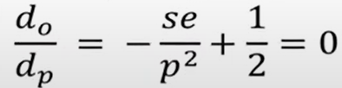

Best size: p = $\sqrt{2sⅇ}$

Separate Instruction and Data Spaces

Most computers have a single address space that holds both programs and data

If this address space is large enough, everything works fine. However, if it’s too small, things become difficult

Separate I and D spaces

Rather than for the normal address spaces, they are now used to divide the L1 cache.

For a 32 bit computer, largest virtual memory is 232 = 4 GB. If you need 4 GB of data for your process, there is nothing left for your instructions.

With separation, each instruction and data spaces has 4 GB of virtual address space.

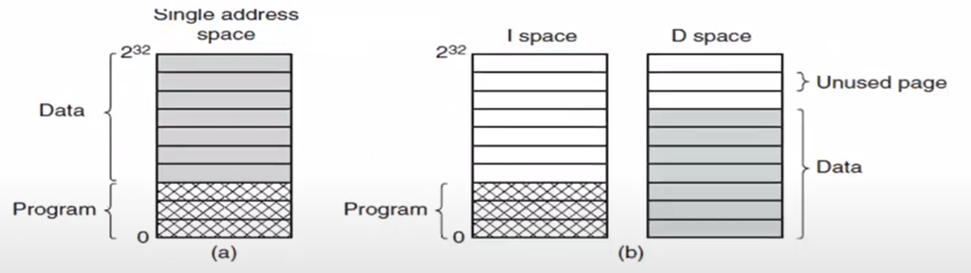

*Figure 3-24. (a) One address space. (b) Separate I and D spaces.*

When you fork a process, we copy just the D space, not the I space. We share I space because they run the same instructions. It is rare that you change instructions.

***Shared pages***

Think about what happens after a fork

Pages that are read-only, such as program text, can be shared, but for data pages sharing is more complicated.

If separate I- and D- spaces are supported, it is relatively straightforward to share programs

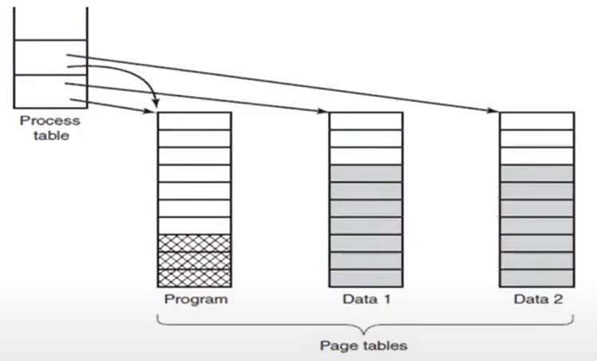



*Figure 3-25. Two processes sharing the same program sharing its page table.*

Advantages of separation:

* I can have larger data space and program space
* I can share constant instructions or some constant data – I am saving lots of memory space
* I don’t have to swat the pages in and out because 2 programs are using the same pages
* Context switch overhead can be reduced

Sharing the data space is not that difficult. After the fork, maybe I am gonna modify only small part of my data space. It is okay to share many pages together with other process.

Context switch overhead can be reduced by page-sharing

* When you switch from P1 to P2, your cache for your program part will not be invalidated bc I am using the same thing. Also most of the time TLB will be same, it will not change.

Sharing data is trickier than sharing code, but it is not impossible

After a fork: Only the data pages that are actually modified need to be copied

This approach, called copy on write, improves performance by reducing copying

I can use standby memory (look from task manager memory tab) as soon as I need new pages. I keep that pages in memory, they are not being used but as soon as I need them by the process, I can use them without any paging in and out. They are outside of working set.

I don’t modify most of the pages, I just read them. I can share them with other processes.

Some of the in-used pages are definitely shared.

***Shared Libraries***

Instead of statically binding libraries, shared libraries (DLL – Dynamically Linked Libraries) can be used.

* Many of the programs we use, use functions provided by OS. For example GUI.dll
* These libraries are in memory and we share them.

Shared libraries are paged!

Shared library routines are located at different memory addresses for each process (see figure)

Solution: position independent code!

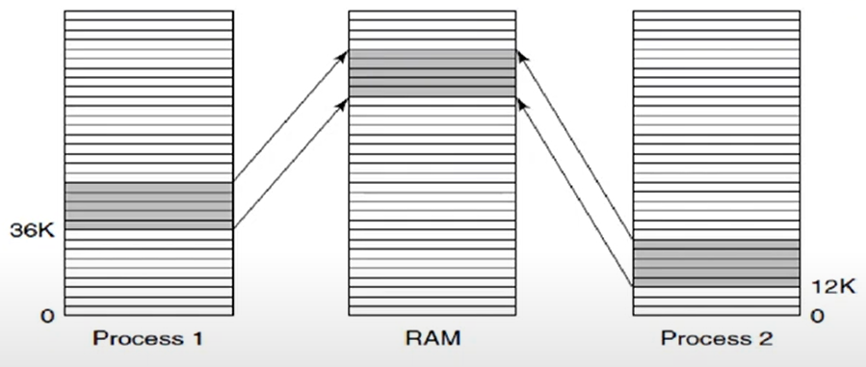

*Figure 3-26. A shared library being used by 2 processes.*

Process 1 thinks that it has GUI functions in its virtual instruction address space. Process 2 thinks same.

In fact in physical memory, these functions are in one place. Both processes are sharing the same GUI functions, same pages.

Only the first process that uses GUI will load shared pages from the disk and rest of them will use them.

Remember soft miss 🡪 Not in page table, but in RAM. All you do is put a link in your page table. Don’t need to load anything from disk.

Soft misses usually happen with shared libraries. You need a function but that function is not in your page table so you realize that, that page is available in the memory. Somebody else is using it. All you do is updating your page table without loading anything from disk.

Without shared libraries, most of the soft misses are hard misses.

That’s why first time you run some of the programs, they are very slow bc it loads its shared pages to the memory. Second time, all the dlls are there so it becomes faster.

Mapped Files

A process can issue a system call to map a file onto a portion of its virtual address space.

Mapped files provide an alternative model for I/O.

Instead, of doing reads and writes, the file can be accessed as a big character array in memory.

Shared libraries are really a special case of a more general memory-mapped files.

If 2 or more processes map onto the same file at the same time, they can communicate over shared memory.

Some part of virtual memory will map to disk, some part will map to physical memory. That’s the advantage of using virtual memory. You can read contents of files, you can write to files just like you are reading and writing from your memory.

mmap

* fd = open(argv[1], O_RDONLY); (int fd)
* fstat(fd, &st) 🡪 gets statistics about file to st (struct stat st)
* ptr = mmap(NULL, st.st_size, PROT_READ, MAP_PRIVATE, fd, 0); (void *ptr)
  + st_size: size of the file
  + PROT_READ: map for reading
  + MAP_PRIVATE: will not be shared, only myself

If mmap is successful, I am pointing to a memory location, at that memory location I am accessing the file.

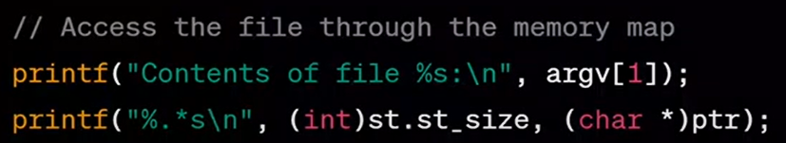

You can issue a system call to map a file onto a portion of your virtual machine.

You can store your objects, data structures on your file but everything looks like you are accessing your memory.

Processes can share some pages in memory and also share some file from disk too. Some form of interprocess communication.

Cleaning Policy

Paging works best when there is an abundant supply of free page frames

Paging systems generally have a background process, called the paging daemon, that sleeps most of the time

* If # of free pages becoming small, then daemon wakes up and begins selecting pages to evict using some page replacement algorithm.

If too few page frames are free, it begins selecting pages to evict using some page replacement algorithm

Usually we keep many pages available (standby). Whenever I need a new page, I don’t do page replacement. I just use one of the available pages. Paging daemon marks some of the pages as unused. It works from time to time.

To use unused pages, I don’t need to write them to disk or replace them.

Only I need to be careful about modified pages. I need to write them to disk if I am gonna replace them. Usually I keep them in memory.

OS Involvement with Paging

There are 4 times when the OS has paging-related work to do:

* process creation time: page table and space allocation
  + OS creates page table and allocates space for the whole process
* process execution time: MMU reset, TLB flushed
* page fault time: find the page number which caused the page fault, find available page, modify page table
* process termination time: release the pages, table entries

During normal execution of process, OS is not involved with paging, it would be very slow if it is involved for each memory access. Everything is handled by MMU.

Everytime you make a memory access, MMU will translate your virtual address to physical address. OS is not involved in that translation.

Page Fault Handling

1. The hardware traps to kernel, saving program counter on stack.
   1. MMU couldn’t find the translated page in TLB, and it said I cannot translate this virtual page.
   2. MMU causes a trap, an interrupt.
   3. MMU saves program counter and some other registers on stack.
2. Assembly code routine started by hardware to save general registers and other volatile info
   1. This assembly code is part of OS, we have written it before.
3. OS discovers page fault has occurred, tries to discover which virtual page needed
4. Once virtual address caused fault is known, OS checks to see if address valid and the protection consistent with access
   1. If address is not valid, there is segmentation fault.
   2. Due to your address structure, some of the addresses are not valid, they don’t belong to you. If you try to write to read-only page, it will cause segmentation fault or write fault.
   3. Remember mmap example above. That page in memory was read-only.
5. If frame selected dirty, page is scheduled for transfer to disk, context switch takes place, suspending faulting process
   1. If there is no other page available other than dirty page, I have to wait until it is written to disk.
6. As soon as frame clean, OS looks up disk address where needed page is, schedules disk operation to bring it in.
7. When disk interrupt indicates page has arrived, tables updated to reflect position, and frame marked as being in normal state.
8. Faulting instruction (that caused page fault) backed up to state it had when it began and program counter is reset
9. Faulting process is scheduled, OS returns to routine that called it.
   1. Process is ready to run doesn’t mean that it’s gonna run as soon as process is ready. Maybe there are other processes in our ready queue.
10. Routine reloads registers and other state information, returns to user space to continue execution.

This is very similar to how we handle regular interrupts either timer or I/O interrupt, I have to save stuffs, I have to find who calls it, I have to handle it accordingly.

***Instruction Backup***

In Fig. 3-27, an instruction starting at address 1000 that makes 3 memory references:

* the instruction word and
* 2 offsets for the operands.

Depending on which of these 3 memory references caused the page fault, the program counter might be 1000, 1002, or 1004 at the time of the fault.

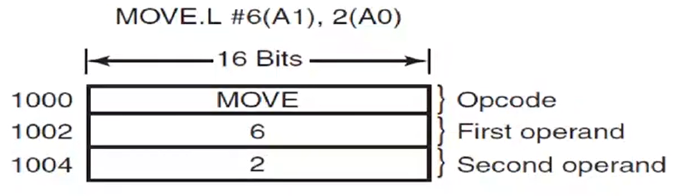

*Figure 3-27. An instruction causing a page fault.*

I am moving some part of my memory to some other part of my memory.

First or second operand may cause a page fault.

We should know which one has caused the page fault and when we come back, we should back up our execution to the beginning of this instruction maybe and complete whatever we left before.

NOTE: Programs can write or read to any part of its own virtual address space.

NOTE: Page file is the file where we keep the virtual pages on disk.

Locking Pages in Memory

If a process starts an I/O read and then blocks, then the page that holds the buffer can be replaced

* While this process blocked, OS might think that the pages that I am using are not used much so they are replaced.
* That’s kinda problematic bc data that I am waiting for is on the disk. While the data is being prepared, the pages that I hold for the data will be paged out by the OS bc they are not used for the last 2 ms.
* I said load this data from disk and write it to this memory location, but that memory location is paged out by the OS.

To prevent this, some pages might be locked or pinned.

* This is very powerful. What if the end-user tries to pin all the pages in to the memory.

Or all I/O can be done on kernel buffers.

* Then it is responsibility of OS to pin these kind of pages.
* Disadvantage is I need to keep copies of many things. One copy is in user space, one copy is in kernel space.

Backing Store

Where do we store the pages on disk?

The simplest algorithm is to have a special swap partition on the disk

Disadvantage: wasted disk space

Alternative: allocate disk space for each page when it is swapped out

Memory is expensive, you don’t want to keep your pages in memory bc it is limited. Also disk is not free either. It is cheaper and larger than memory but it doesn’t mean that we have infinitely large physical disk areas. It costs money. We don’t have terabytes of disk space for swapping in and out. We have to be efficient.

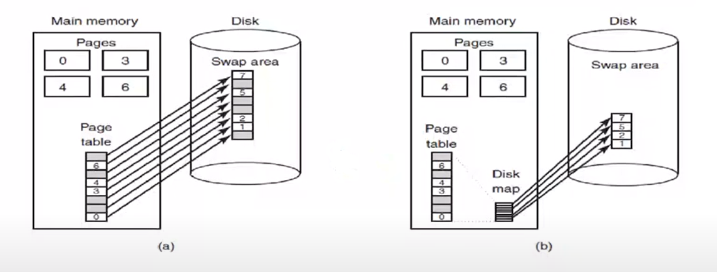



*Figure 3-28. (a) Paging to a static swap area. (b) Backing up pages dynamically*

Some part of pages are in memory and some part are in disk. Where do we keep all that data in disk?

* a
  + I have 8 pages of virtual address space.
  + It looks like I keep my space for whole virtual memory on the disk. I keep empty positions for pages too.
  + If I need to write page 0 to disk (maybe it will be replaced), I know where it is gonna be written. It is gonna be written in red part.
  + This is very nice but waste of disk space.
  + On a 32 bit computer, total size of virtual memory is 4 GB. If each process holds 4 GB on disk, that’s not good. Most of the pages out of these 4 GB will be empty.
  + For 64 bit computer, total address space is usually 248. We are talking about petabytes of disk space. We don’t have that kind of disk space. That’s too big. Even if we do, that’s waste of disk space utilization.
* b
  + We only keep pages that are not empty in disk.

Separation of Policy and Mechanism

***Split policy from mechanism***

Memory management system is divided into 3 parts:

1. A low-level MMU handler: assembly, machine dependent
   1. TLB operations are done in assembly by OS.
2. A page fault handler that is part of the kernel: machine independent, mechanism for paging
   1. It does the paging but it doesn’t know what it is doing. It doesn’t know the policy, algorithm of paging. It doesn’t know which pages to replace. It doesn’t know what it is optimizing.
   2. Page replacement algorithms are machine independent and written in high-level language.
3. An external pager running in user space: policy, machine independent, portable
   1. All smart logic is in here. It is very complicated so you don’t want to run it in kernel space bc any error it makes, it may cause whole OS to crash.

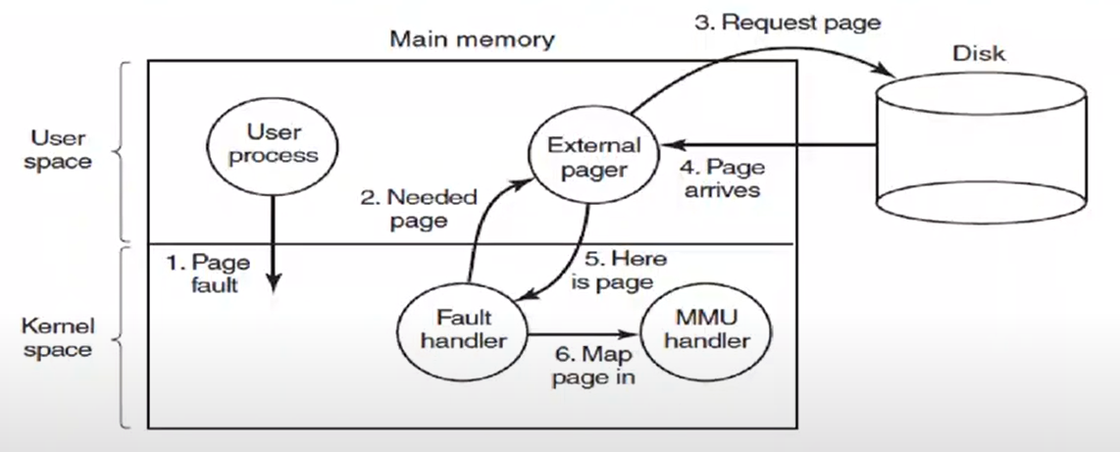

*Figure 3-29. Page fault handling with an external pager.*

When page fault happens, page fault handler finds the page fault. It says “This is the page that caused the page fault. I am gonna need to load it.”.

External pager finds the page to be replaced, runs the page replacement algorithm. Then does the page replacement if it is required. It cannot load the data from disk by itself. It will have to ask this from the OS. So it makes a few system calls maybe. These calls are expensive, why don’t we run this in kernel space? Because that is not modular, not portable. I sacrifice some speed and performance for the favor of modularity.

MMU handler will set up the page table.

Policy is your brain, mechanism is your arms, legs, fingers.

R and M bits are not accessible from the external pager. They are privileged positions. I will have to ask OS to do that. That requires system calls. That is expensive.

Many switches to the kernel, many system calls BUT this is very modular and easier to manage.

WE ABSTRACTED AWAY THE CPU USING PROCESSES

WE ABSTRACTED AWAY THE MEMORY USING ADDRESS SPACES

WE ARE GONNA ABSTRACT AWAY THE SECONDARY STORAGE USING FILES

Segmentation

Nowadays, nobody uses it because paging is good enough.

The virtual memory discussed so far is one-dimensional bc the virtual addresses go from 0 to some maximum address, one address after another.

For many problems, having 2 or more separate virtual address spaces may be much better than having only one.

Sometimes I like to use different categories for different parts of the virtual memory. Separate our memory into thousands of segments. Like I space and D space.

Segments are up to programmer. He/She can say I need 10 segments, etc.

Examples of tables generated by compiler:

1. The source text (program you are gonna compile) being saved for the printed listing
2. The symbol table, names and attributes of variables
3. The table containing integer and floating-point constants used
4. The parse tree, syntactic analysis of the program
5. The stack used for procedure calls within compiler

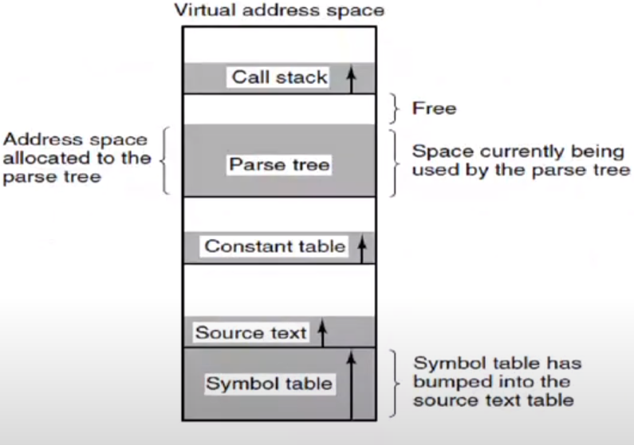

*Figure 3-30. In a one-dimensional address space with growing tables, one table may bump into another.*

Each segment has known size defined by programmer.

For the program in figure, give me 5 virtual memory spaces. I am gonna use them differently. Each one starts from address number 0.

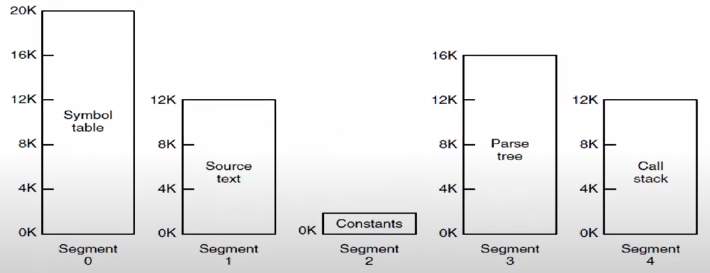

*Figure 3-31. A segmented memory allows each table to grow or shrink independently of the other tables.*

OS can help me shrink and grow them.

I don’t care where they live in physical memory.

A segment is a logical entity, which the programmer is aware of and uses as a logical entity.

A segment might contain a procedure, or an array, or a stack, or a collection of scalar variables, but usually it does not contain a mixture of different types.

If each procedure occupies a separate segment, with address 0 as its starting address, the linking of procedures compiled separately is greatly simplified.

With one dimensional memory, changing one procedure’s size can affect the starting address of all the other (unrelated) procedures in the segment.

If I have used standard virtual memory:

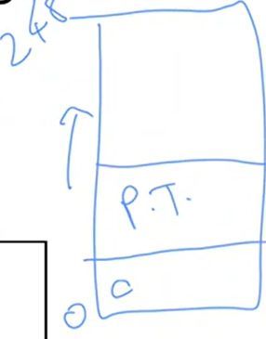If size of my constant segment becomes larger, then I need to push parse tree to upwards.

Using very high memory for each segment doesn’t solve the problem all the time.

With segmentation, I let the hardware and OS to solve the problem for me. I don’t care how much memory I have for the parse tree. If I need more memory, I ask to OS. If I don’t need that much memory I ask to OS. All I know is I start from 0 to some number that I defined.

In a segmented system, a shared graphical library (graph.dll) can be put in a segment and shared by multiple processes, eliminating the need for having it in every process’ address space. I don’t know where this library lives in physical memory, but draw() function’s address is always 0.

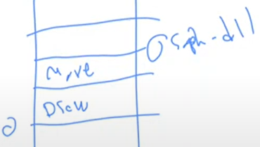

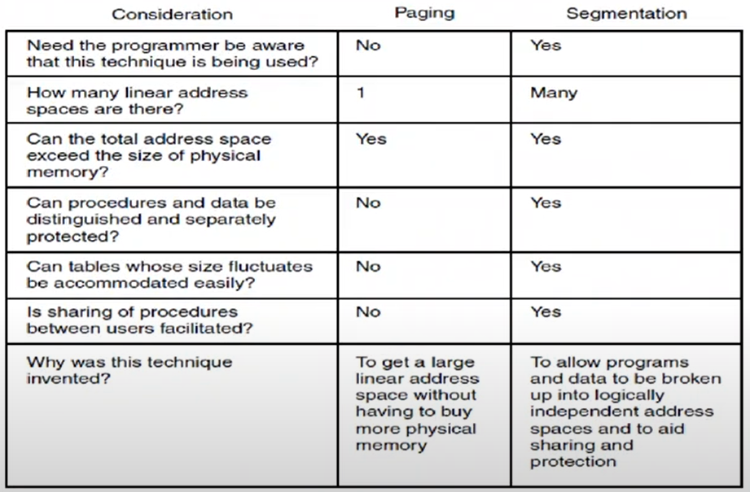

As a programmer I cannot protect but as OS there are ways of doing this.

*Figure 3-32. Comparison of paging and segmentation*

Programmer specifies number of segments and initial size of the segments.

With paging, all I care is virtual memory size which is more than enough.

This is one advantage of paging over segmentation.

Implementation of Pure Segmentation

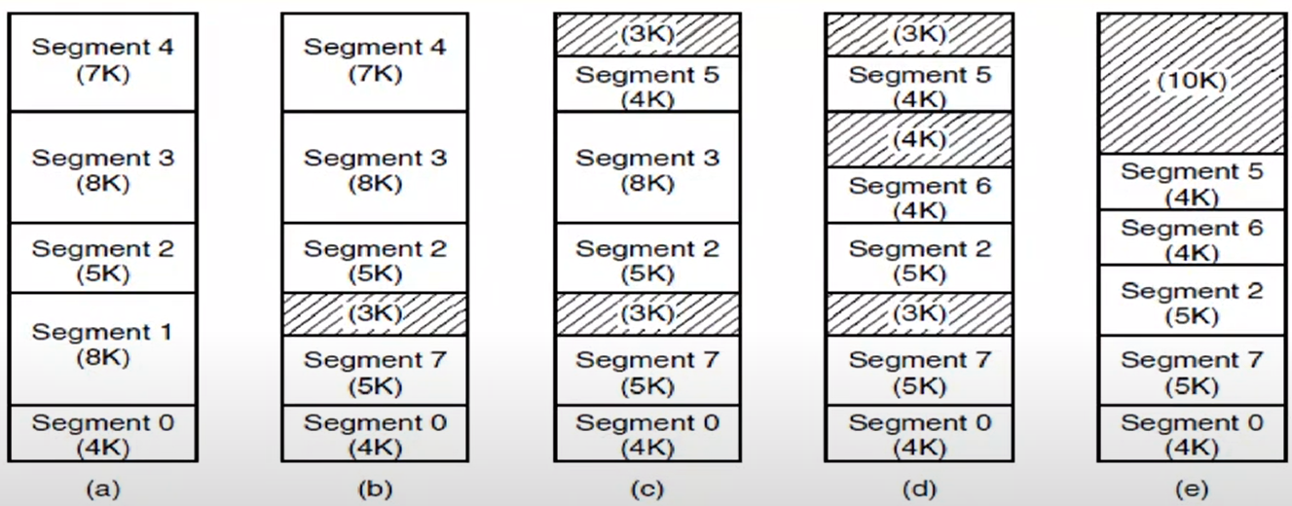

*(a)-(d) Development of checkerboarding.*

*(e) Removal of the checkerboarding by compaction.*

This brings back the problem of external fragmentation. OS and hardware have to move the segments around.

So pure segmentation is never implemented. Segmentation is always implemented with the help of the paging. I page each of the segments. I don’t have to move anything around.

Then each segment has its own page table. My page tables will tell me where each of my segment pages are.

MULTICS

Segmentation idea started with MULTICS

The MULTICS OS was one of the most influential OSs ever, having had a major influence on topics as disparate as UNIX, the x86 memory architecture, TLBs, and cloud computing.

It was started as a research project at M.I.T. and went live in 1969.

The last MULTICS system was shut down in 2000 bc they couldn’t find the spare parts for the computer itself (hardware is not supported anymore), a run of 31 years.

UNIX is simplified version of MULTICS

The UNIX has affected LINUX, WINDOWS NT, MAC OS, ANDROID, IOS, etc.

Windows changed a lot. Only name is the same with first Windows versions.

So running same OS for 31 years is huge thing.

Segmentation with Paging: MULTICS

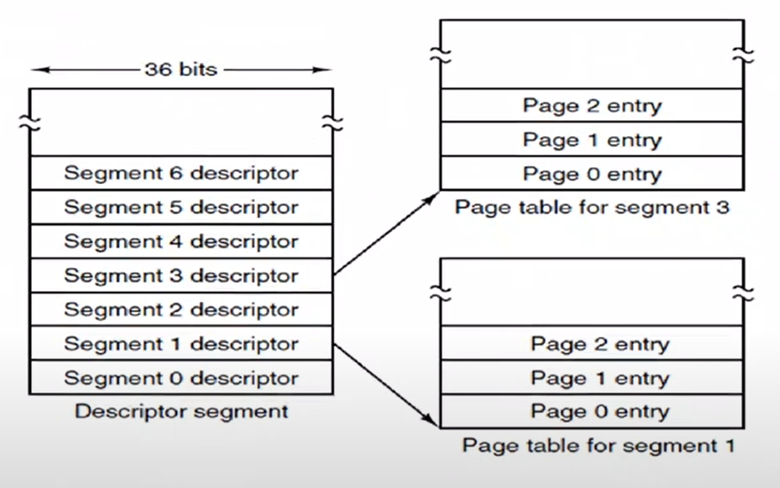

*Figure 3-34. The MULTICS virtual memory.*

*The descriptor segment pointed to the page tables.*

You can have 218 segments with 36 bits.

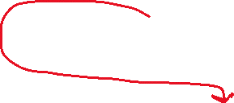

You should say how many segments you want and size of each segment in terms of KB. Then OS will page them for your.

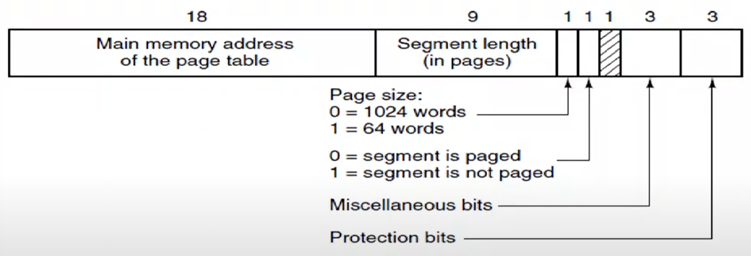

*Figure 3-34. The MULTICS virtual memory.*

*A segment descriptor. The numbers are the field lengths.*

length of the segment could be at most 29 pages. Each page could be either 64 words or 1 kilo words. So 29 . 210 = 219 🡪 each segment could be half a MB.

If you like, you may prevent paging for your segment.

Protection bits say that this segment is read-only/write-only/executable/etc.

Miscellaneous bits are used by OS.

This is how a process’s memory is defined. You define your segments.

How about virtual memory? How about the memory that end users use?

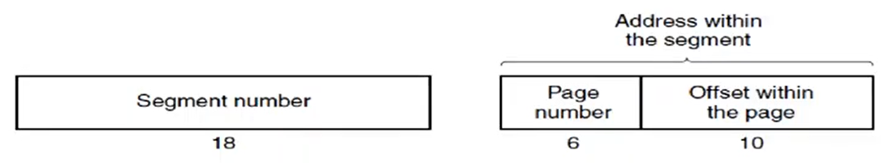

*Figure 3-35. A 34-bit MULTICS virtual address.*

Your virtual memory is 234.

Each page could be at most 1 KB so 10 bits for offset is enough.

We did only 16 bit part with virtual paging.

All of these complications are handled by MMU during runtime.

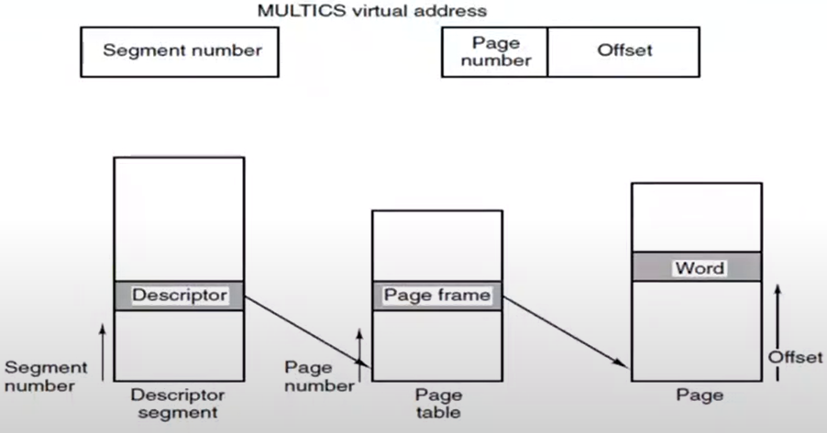

*Figure 3-36. Conversion of a two-part MULTICS address into a main memory address.*

This is too slow so they invented TLB.

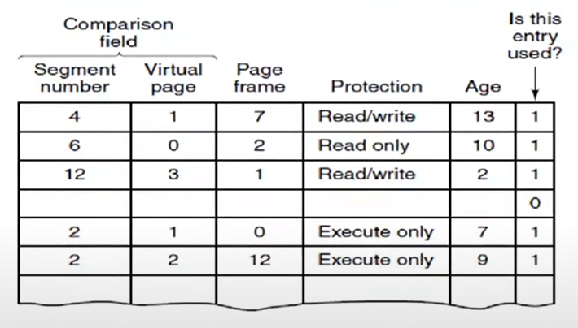

*Figure 3-37. A simplified version of the MULTICS TLB. The existence of two page sizes made the actual TLB more complicated.*

Given any virtual address, I took segment number and virtual page and compare in my TLB, in my cache and do I have it or not have it.

If I have it, this (number in page frame part) is the page frame in my physical memory.

If I don’t have it, then I have to do page fault.

I do rest of the things as before.

Segmentation with Paging: The Intel x86 - NOT MUCH IMPORTANT, YOU CAN SKIP

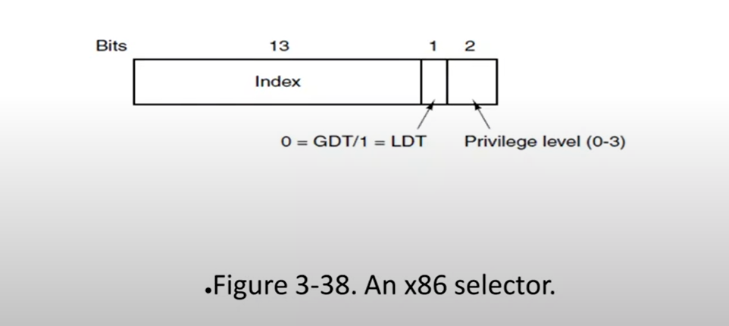

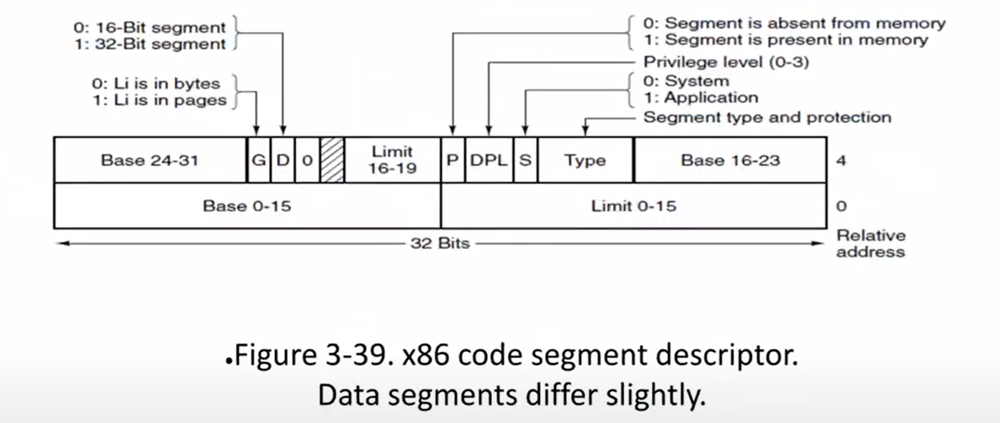

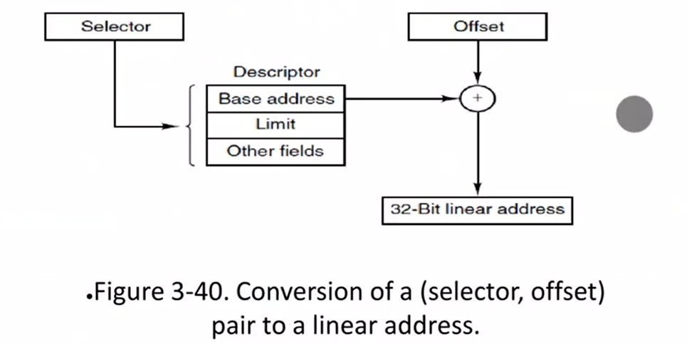

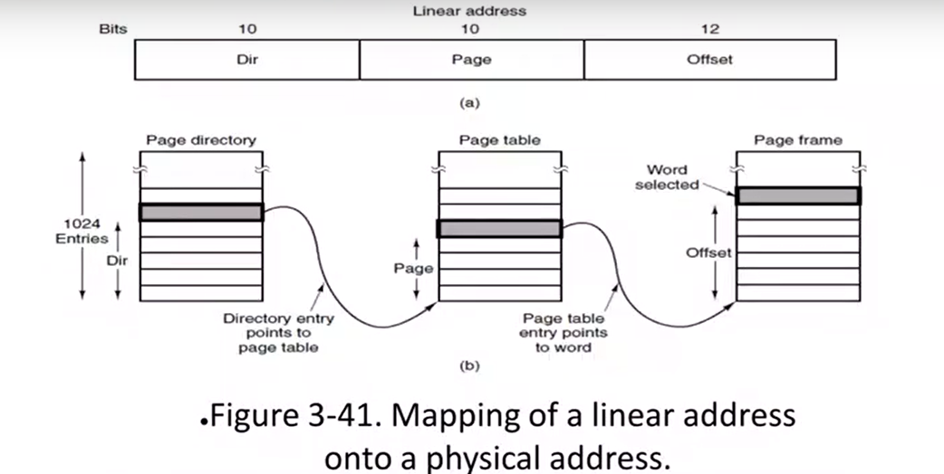

Main Structure of Linux Processes

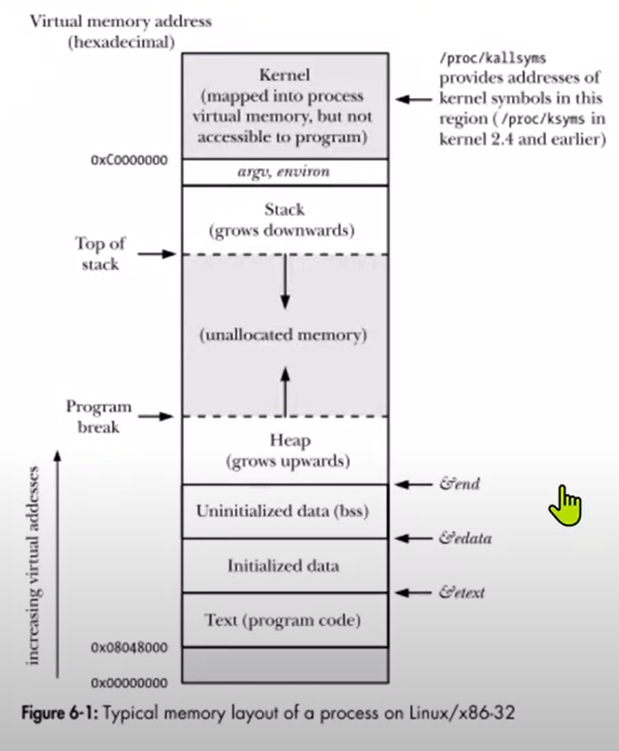

Linux is already making this assumption of my process space is divided like this. So it has its own idea for the different segments of the program. It is optimized that way. That may be the reason why Linux doesn’t use segmentation but only paging.

Segmentation is better at fluctuating memory size than paging. With segmentation, OS can grow or shrink the segment sizes. OS uses paging underneath. So it can add as many pages it wants as long as segment size and page sizes are okay.

In paging, you have just 1 linear virtual address space. You have to manage this space by yourself.

We don’t run this kinda problems with todays big virtual memories. There is no way that you can fill large space.

Both segmentation and OS are done by OS.

With segmentation, we split each box to segments in the above figure. OS sets up all those segments. OS will store them wherever it likes but it will never tell you that “you don’t have enough space, you have to move things around, etc.”